**ANALYSING INFLATION AND RECESSION IN THE UK: UNDERSTANDING PATTERNS AND EFFECTS**

***NAME:***

***ID:***

**Abstract**

***Purpose***

The research aims to investigate the economic stability of the UK, identify the link between key economic variables and recession and inflation patterns, identify difficulties connected with recession and inflation patterns and make recommendations for effective mitigation techniques. The study focuses on providing significant insights into the mechanisms of economic stability in the UK and assisting evidence-based policy decisions.

***Methods***

The study adopts a descriptive research approach to examine inflation and recession patterns in the UK from 1980 to 2022. In order to explore the patterns, a deductive approach and a mono-quantitative strategy have been chosen. Data has been gathered from sources such as IMF, Macrotrends, ONS and Bank of England. The study leverages the LSTM machine learning model for data analysis.

***Scope***

The scope of this entire research study is to encompass a comprehensive analysis of economic stability in the UK with a specific focus on recession and inflation patterns. Additionally, the entire study also uses LSTM machine learning models for evaluating the influence of diverse macroeconomic indicators to identify challenges associated with significant economic phenomena.

***Findings***

The value of loss and MAE on the test set of recession is 0.023 and 0.1253. The value of the mean absolute error is 0.13 or 13%, indicating that the developed predicted model is highly accurate for the determination of trends and patterns affecting recession in the UK. The accuracy obtained from the LSTM model is 99.99% indicating that the model has been able to properly understand the trend and patterns of recession in the UK. On the other hand, the accuracy of the LSTM model for inflation is 96.4%, indicating that the model is highly accurate for measuring the factors affecting inflation in the UK.

***Conclusion***

Based on the research it can be concluded that recession and inflation has seen significant changes in the UK from 1980-2023. It can also be concluded that economic factors like GDP growth, Money Stock, Debt and others properly helps to understand recession and inflation trends thus meeting all the objectives

***Recommendations***

It is advised that it can be simpler to study the patterns and trends of inflation and recession in the nation if the dataset has data over a larger time span. Only one nation(UK) and a limited time period are examined for the current study.

**Table of contents**

Chapter 1: Introduction 15

1.1 Background of the study 15

1.2 Problem statement 16

1.3 Research rationale 17

1.4 Research aims, objectives, questions, and hypothesis 17

1.4.1 Research Aim 17

1.4.2 Objectives 18

1.4.3 Questions 18

1.4.4 Hypothesis 18

1.5 Research significance 19

1.6 System block diagram 20

Chapter 2: Literature Review 21

2.1 Introduction 21

2.2 Understanding patterns of recession and inflation 21

2.3 Evaluation of the link between financial stability and patterns of recession and inflation 22

2.4 Analysing the link amongst employment rate, GDP Growth, Money Stock, Public debt, Government Expenditure and Interest Rate and patterns of recession and inflation 24

2.5 Identification of the challenges related to developing economic stability from the patterns of recession and inflation 25

2.6 Understanding of the causes behind the identified challenges from the patterns of recession and inflation 27

2.7 Analysis of existing strategies used to mitigate the issues related to recession and inflation 28

2.8 Theoretical underpinning 30

2.9 Literature gap 32

2.10 Conceptual Framework 33

2.11 Summary 33

Chapter 3: Methodology 35

3.1 Introduction 35

3.2 Research Design 35

3.3 Research Approach 35

3.4 Research Strategy 36

3.5 Research Choice 36

3.6 Requirements 37

3.7 Possible Solution 38

3.8 Implementation 39

3.9 Test Schedule 40

3.10 Chapter Summary 41

Chapter 4: Results 42

4.1 Introduction 42

4.2 Analysis 42

4.2.1 Factors stipulating recession in the UK 42

4.2.2 Factors triggering inflation in the UK 46

4.3 Contribution of Machine Learning Model to Predict Recession and Inflation in the UK 52

4.3.1 LSTM Model for interpreting aspects catering recession in the UK overtime 52

4.3.2 LSTM model for factorial analysis regarding inflation in the UK 56

4.4 Visualization Using PBI Dashboard 60

4.4.1 Yearly Recession and Inflation PBI Reports 60

4.4.2 Monthly CPI, CPIH and GDP Growth PBI Reports 62

4.5 Findings 64

4.6 Chapter Summary 64

Chapter 5: Discussion 66

5.1 Introduction 66

5.2 Evaluation of the functionality of the software analysis 66

5.3 Exploring economic stability in the UK focusing on the significant patterns of both recession and inflation 67

5.4 Understanding variations in employment rate, GDP Growth, Money Stock, Debt, Government Expenditure and Interest Rate influencing the patterns of recession and inflation 68

5.5 Challenges associated with patterns of recession and inflation 68

5.6 Identification of causes of challenges to demonstrate recession and inflation Fluctuations 69

5.7 Recommendation for efficient mitigation of inflation and recession 69

5.8 Summary 70

Chapter 6: Conclusion and Recommendations 71

6.1 Conclusion 71

6.2 Limitations of the research 72

6.3 Recommendation 72

6.4 Significance for future researchers, policy makers and other stakeholders 73

Reference list 74

Appendices 83

Appendix 1: Python Codes 83

**List of Figures**

Figure 1: The change in GDP from 2000 to 2019 in the UK 16

Figure 2: System block diagram 20

Figure 3: Recession synchronisation on a global scale 23

Figure 4: Yearly contributions and rates of inflation 24

Figure 5: Challenges of recession and inflation 27

Figure 6: Total trade trend in the UK before and after Brexit and COVID 28

Figure 7: Policies for tackling recession 29

Figure 10: Conceptual framework 33

Figure 11: Deductive approach 36

Figure 12: Data collection sources 38

Figure 13: Recession and non-recession period 42

Figure 14: Consumer spending, debt, employment rate, interest rate and money stocks in the pre-recession period 43

Figure 15: Consumer spending, debt, employment rate, interest rate and money stocks in recession period 44

Figure 16: Consumer spending, debt, employment rate, interest rate and money stocks in the post-recession period 45

Figure 17: UK Inflation rate over the Years 46

Figure 18: UK Inflation Rate and GDP Growth 47

Figure 19: UK Inflation rate and Debt over the years 48

Figure 20: UK Inflation rate and Employment Rate 49

Figure 21: UK Inflation Rate and Interest Rate 50

Figure 22: UK Inflation rate and Government Expenditure 51

Figure 23: UK Inflation Rate and Money Stock 52

Figure 24: Selection of target variables and normalisation 53

Figure 25: MAE and loss of the LSTM Model for Recession 54

Figure 26: Model summary of the LSTM model for Recession 54

Figure 27: Actual and predicted trendline for the recession in the UK 55

Figure 28: Target Variable Selection by defining the sequence length 56

Figure 29: Building and Training Process of the LSTM Model 57

Figure 30: Training and Validation Performance of the LSTM model 58

Figure 31: Model Summary with an Accuracy Score of the Model 58

Figure 32: Actual vs. Predicted Inflation Rate 59

Figure 33: UK Inflation and Recession Yearly Summary PBI 59

Figure 34: UK Inflation and Recession Yearly Data Table PBI 59

Figure 35: UK Yearly Inflation Details PBI 59

Figure 36: UK Yearly Recession Datiles PBI 59

Figure 37: UK Monthly Inflation and GDP Growth Summary PBI 59

Figure 38: UK Monthly CPI, CPIH and GDP Growth Data Table PBI 59

Figure 39: UK Monthly Consumer Product Inflation Details PBI 59

Figure 40: UK Quaertrly and Yearly GDP Growth Details PBI 59

Figure 41: UK Monthly Household Inflation Details PBI 59

**List of Tables**

Table 1: Concept on causes and repercussion variables 18

Table 2: Timeline of the proposed study 39

**Abbreviations**

|  |  |
| --- | --- |
| ***Abbreviations*** | ***Complete Phrase*** |
| UK | United Kingdom |
| ML | Machine learning |
| LSTM | Long short-term memory |
| GDP | Gross Domestic Product |
| IMF | International Monetary Fund |
| ONS | Office of National Statistics |
| EMDE | Eastern Mediterranean economies |
| EAP | East Asia and Pacific |
| ECB | European Central Bank |
| MMT | Modern Monetary Theory |
| US | United States |

**Declaration**

I declare that this research is done on my own. I also declare that I have conducted this research by using all authentic sources as well as journal articles without hampering the privacy of the authors.

**Acknowledgement**

I would like to sincerely thank my university processor for all of his helpful suggestions, knowledge, and leadership since the very beginning of my research. I appreciate the continued help that was successful during the full study period.

# Chapter 1: Introduction

## 1.1 Background of the study

Recession and inflation are key issues that prohibit economic growth in a country. A sudden decline in the financial activities of a country which can last more than a month and affect employment, business, income and other economic indicators is known as a recession. Inflation is the rise of the price rate over time, which can be caused by recession (Bove, 2022). Although they are fundamentally different financial occurrences, recessions and inflation are closely linked. Since firms reduce production while raising prices in response to greater expenses, high inflation rates may represent the beginning of a recession (Tretina, 2022). In 2023, it has been forecasted that there will be a strong threat of recession in a number of nations, especially those in Europe and North America (World Bank, 2022). The UK holds the highest anticipated chance of a recession at 75% (Atkinson and Ichikura, 2022). The global recession of 2007 to 2008 imposed pressure on the British economy from both domestic and global variables such as banking, political stability, supply chain and demand, and the UK faced a huge decline in its financial growth (Zhu, Kavanagh and O’Sullivan, 2020). By 2010, the UK had experienced substantial expansion, and in the following years, it entered a developing phase. However, the high rise in GDP, consumption and development that characterised this era of prosperity, was quickly replaced by a sharp decrease in domestic savings and gross expenditure in the wake of the Brexit Referendum in 2015–2016 (Victor et al., 2021). Similarly, the COVID-19 crisis has affected the UK financial health significantly affecting the supply chain and demand of the country (Zhu, Kavanagh and O’Sullivan, 2020). The possibility exists that an inflation phase, characterised by higher costs and unemployment rates, could develop if the economy enters a deeper recession as a result of shocks to supply and demand. The ***figure 1*** below indicates the changes in GDP from 2000 to 2019. The blue line indicates the GDP change in the UK which indicates that in 2000 the GDP of the UK had a sharp decline which fluctuated till 2012. After 2012 the UK GDP has faced slow fluctuation as shown in the graph.

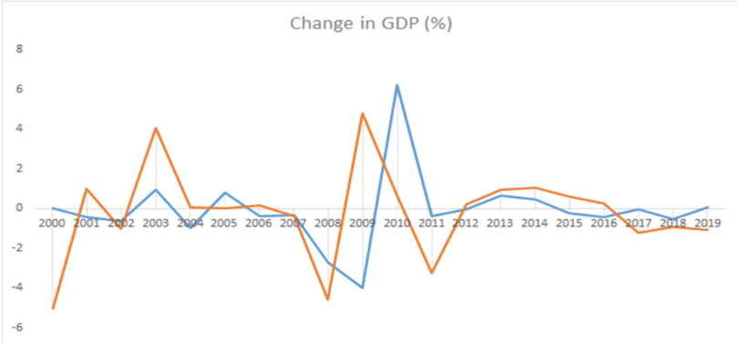

#### Figure 1: The change in GDP from 2000 to 2019 in the UK

(Source: Victor et al., 2021)

## 1.2 Problem statement

The UK is now facing a difficult and serious economic issue marked by a large spike in inflation rates. This problem, exacerbated by circumstances such as rising energy prices, food shortages and the continued effects of COVID-19 pandemic, has put significant strain on the economic stability of the country (International Monetary Fund, 2023). Inflation rates, which was around 11.1% as of October 2022, have reached alarming levels, wreaking adverse effects on various economic sectors, including consumer purchasing power, corporate profitability, and overall economic well-being (Clark, 2023). Moreover, the increased risk of recession for the UK by the end of 2023 is posing significant risk to the nation (Partington, 2023). The main issue at hand is the rising economic dilemma in the UK, which has brought about a huge number of adverse consequences. Strikingly, the significant increase in the cost of essential commodities like food and energy has forced a huge stress on households, making it progressively difficult for an average citizen to fulfil basic demands (BBC, 2023). Rising energy costs have brought about rising energy expenditures for organisations and individuals, influencing both the cost of living and functional expenses of firms (Francis-Devine et al., 2023). These challenges, alongside rising mortgage payments, tax increments and a volatile labour market, have resulted in huge economic instability.

This research intends to resolve the issue of rising inflation and recession in the UK by examining its patterns, causes, and consequences and providing effective methods to restrict its adverse consequences. The issue that has been chosen for this research to address is twofold. Firstly, the study tends to focus on how economic stability is linked with both inflation and recession patterns in the UK. This involves investigating the causes and their consequences on different economic variables such as purchasing power, company profitability and overall well-being. Secondly, the research seeks to give solutions and suggestions to stakeholders using a data-driven approach and machine learning techniques, especially the Long Short-Term Memory (LSTM) model. Therefore, the research is poised to deliver actionable insights and recommendations to fortify the problem of recession and inflation of the UK to maintain an economic stability, safeguarding the prosperous and resilient future of the nation.

## 1.3 Research rationale

The motivation for conducting this research originates from a deep concern for the economic wellbeing and stability of the UK. As the country grappled with the effects of growing inflation and recession, a compelling need developed to investigate the fundamental causes, patterns and consequences of these economic issues. The desire to provide clarity and guidance in times of economic uncertainty has been a driving force. The motivation has been fuelled with the intention to provide stakeholders, businesses and individuals the knowledge and tools they need to make informed decisions. The rising inflation rates, aggravated by reasons such as rising energy prices and global events like the pandemic, required a deeper look. Furthermore, the ever-increasing complexity of the modern economy, interwoven with global dynamics, demanded a data-driven strategy. The possibility of using modern approaches, such as machine learning algorithms like LSTM, to solve these economic difficulties gave a sense of novelty and urgency to the research effort.

## 1.4 Research aims, objectives, questions, and hypothesis

### 1.4.1 Research Aim

The principal aim of this entire research study is to understand the patterns, causes and influence of recession and inflation in the UK from the period of 1980 to 2022.

### 1.4.2 Objectives

* To explore the economic stability of the UK by focusing on the significant patterns of both recession and inflation by using the LSTM ML model.
* To determine the variations of employment rate, GDP Growth, Money Stock, Debt, Government Expenditure and Interest Rate influencing the patterns of recession and inflation of the UK by using LSTM ML model.
* To identify the challenges associated with specific patterns of recession and inflation conditions in the context of the UK economic stability by using the LSTM ML model.
* To recognise the causes of challenges by utilising the ML algorithm of Long Short-Term Memory (LSTM) to demonstrate recession and inflation fluctuation in the UK.
* To recommend efficient strategies for mitigating the issues in this context of recession and inflation in the UK.

### 1.4.3 Questions

* How to understand UK economic stability by considering the significant patterns in inflation and recession?
* What are the variations of employment rate, GDP Growth, Money Stock, Debt, Government Expenditure and Interest Rate influencing the patterns of recession and inflation of the UK?
* What are the challenges associated with specific patterns of recession and inflation conditions in the context of the UK economic stability?
* Which factors have led to the challenges that have influenced recession and inflation patterns in the UK?
* What are the possible strategies for mitigating the issues associated with recession and inflation patterns in the UK?

### 1.4.4 Hypothesis

|  |  |
| --- | --- |
| ***Concepts on Causes*** | ***Concepts on Repercussions*** |
| Recession, Inflation (Patterns and Effects) | Economic Stabilisation in the UK |
| ***Sub-variables:***  GDP growth, Money stocks, employment rate, government debt, interest rate, Government expenditure |

##### Table 1: Concept on causes and repercussion variables

**For Recession**

***Null Hypothesis (H0):*** Economic stabilisation is not influential in the context of patterns and trends of recession.

***Alternate Hypothesis (H1):*** Economic stabilisation is influential in the context of patterns and trends of recession.

**For Inflation**

***Null Hypothesis (H0):*** Economic stabilisation is not influential in the context of patterns and trends of inflation.

***Alternate Hypothesis (H1):*** Economic stabilisation is not influential in the context of patterns and trends of inflation.

## 1.5 Research significance

The significance of this research mainly lies in its comprehensive exploration of the patterns and causes behind the effects of recession and inflation in the economy of the UK. This study is meant for policymakers and government agencies responsible for shaping economic policies in the UK. By shedding light on the patterns, causes and effects of both the recession and inflation, the research tends to provide them with valuable insights to formulate efficient policies that easily promote economic stability, management of inflation and growth of employment. It also provides a deeper understanding of the economic environment, helping the policymakers to provide more informed financial decisions to develop robust strategies for navigating economic challenges, specifically during times of recession and inflation.

## 1.6 System block diagram

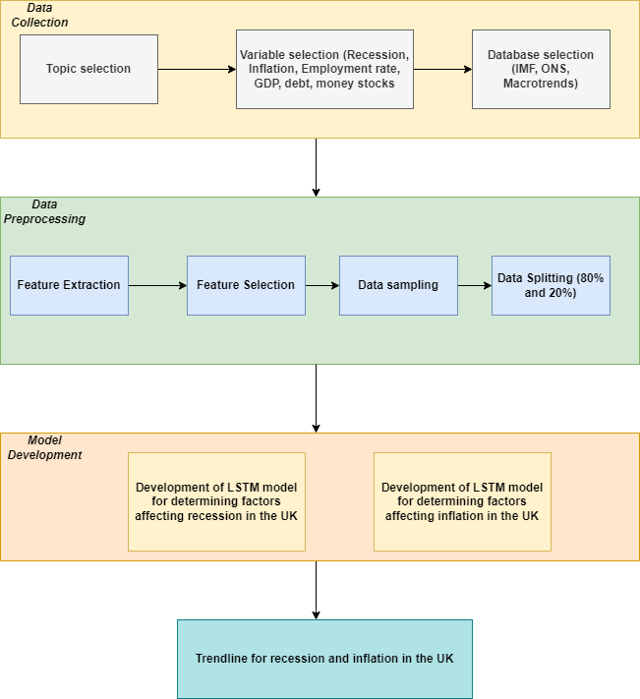

#### Figure 2: System block diagram

***Figure 2*** demonstrates the process of collecting data and developing the LSTM model for determining the factors that create an effect on recessions and inflation in the UK. For the collection of data, different secondary databases like IMF, ONS and Macro Trends have been considered. Feature extraction, feature selection and data splitting have been performed for the development of the LSTM model.

# Chapter 2: Literature Review

## 2.1 Introduction

The literature review for this entire research project mainly delves into exploring diverse critical aspects related to recession and inflation in the context of economic stability. This chapter facilitates the exploration of the intricate patterns and dynamics of economic events, thereby providing valuable insights into these origins and evolution. It serves as the foundation for understanding the patterns, effects, and mitigation strategies associated with recession and inflation. This chapter also investigates the existing strategies employed to mitigate the adverse effects of recession and inflation. It provides a comprehensive backdrop for the subsequent analysis of the research.

## 2.2 Understanding patterns of recession and inflation

Recession and inflation are fundamental economic phenomena that profoundly influence the prosperity and stability of nations. This specific section of the literature review mainly seeks to delve into the intricate patterns and dynamics of these phenomena to provide a comprehensive understanding of causation and development. Recession is often characterised by a significant decline in economic activity and can easily manifest in diverse forms (Matysiak, Sobotka and Vignoli, 2020). The underlying causes are multifaceted and can involve factors such as sudden reductions in consumer spending, high unemployment rates, and reduced business investment. Additionally, the patterns of recession may vary in intensity and duration, ranging from short-lived economic downturns to more prolonged as well as severe crises (Cicceri, Inserra and Limosani, 2020). Thus, the complicated nature of patterns and causes of recession encompasses diverse economic indicators and underscores the requirement for a multifaceted approach to address this critical economic phenomenon.

Inflation is the sustained increase in the general price level of goods as well as services over time and can also significantly influence the cost of living for individuals along with the profitability of businesses (Girdzijauskas et al., 2022). Victor et al. (2021) have stated the patterns of inflation that can easily be affected by factors such as rising production costs, government policies and excess demand. Thus, the variation in inflation rates has been a permanent illustration of its diverse patterns and its effects on economies. The dynamics of these two economic phenomena are intertwined, as periods of recession often lead to deflationary pressures, while inflation can exacerbate all economic challenges during times of recession. It is essential to understand these patterns comprehensively to evaluate effective strategies to mitigate the adverse effects of recession and inflation.

## 2.3 Evaluation of the link between financial stability and patterns of recession and inflation

In the global scenario, recession and inflation both have significant effects on different countries. Over the past seven decades, there have been four worldwide recessions which occurred in 1975, 1982, 1991, and 2009 (Kose, Sugawara and Terrones, 2020). Each of these periods saw a massive decline in the yearly real per capita worldwide GDP, which was followed by the decline of other important global economic activity indexes like supplying, producing, selling, buying, and the consumption. The worldwide recessions caused serious financial and economic disruptions in many nations throughout the world and were closely synchronised on a global scale. Recession around the world has different effects in various nations like the US, UK, Asian countries and more. In developed nations as opposed to Eastern Mediterranean economies (EMDE) throughout the global recession, average per capita output decreased significantly by 70% (The World Bank, 2023). The average per capita growth rate declined more sharply in low-income countries by 95% than in EMDEs (The World Bank, 2023) . Even during global economic downturns, the East Asia and Pacific (EAP) and South Asia (SAR) areas kept developing. However, the per capita output fell in the EMDA region especially those that depend primarily on export and industrial goods (IMF, 2019). Figure 3 below indicates the synchronisation of the recession on a global scale.

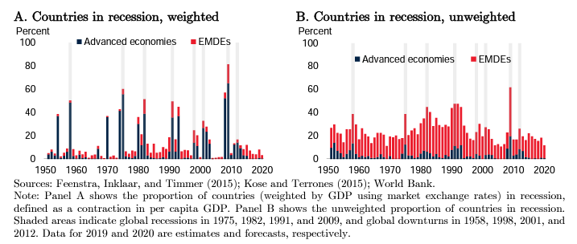

#### Figure 3: Recession synchronisation on a global scale

(Source: Kose, Sugawara and Terrones, 2020)

According to Batayneh, Al Salamat and Momani (2021), earnings have not risen as quickly as community demands in numerous countries that are less developed. Personal savings are minimal in these nations, hence there are few resources which are ready to increase community capital. In these nations, the rise in GDP was just half as compared with the developing nations during phases of moderate inflation. The output growth is likely to be smaller during periods of high inflation (Ibrahim, Aluko and Vo, 2022). Moreover, a high level of inflation has a negative effect on companies and individual lifestyles in a number of ways like reducing real incomes and increasing inequality. As a consequence, the Central Bank drastically tightens its rules on monetary policy and the flow of credit to the real economy decreases and borrowing prices increases, naturally reducing demand (Ibrahim, Aluko and Vo, 2022). Furthermore, as declared by Gern, Jannsen and Sonnenberg (2023), energy prices were initially the only factor driving the increase in inflation since 2021, but it quickly extended to other consumer products. Inflation in the European area began to rise in 2021, far beyond the European Central Bank (ECB) inflation objective and it reached significant heights of more than 10% in 2022 (Reuters, 2022). The rise was followed by the consequences of the COVID-19 pandemic globally. The Russian invasion of Ukraine in 2022 increased the upward demand on energy costs, particularly for gas and electricity. Despite a recent slight decrease inflation is still significantly higher than the target level of the ECB (Yagi and Managi, 2023). Therefore, it can be said that recession and inflation are linked with financial stability of a country. ***Figure 4*** demonstrates the rate of inflation and contributors to inflation.

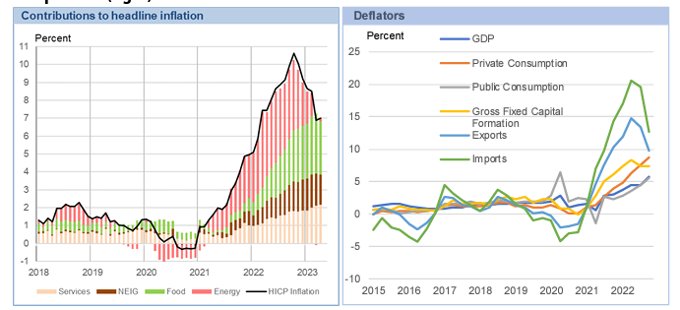

#### Figure 4: Yearly contributions and rates of inflation

(Source: Gern, Jannsen and Sonnenberg, 2023)

## 2.4 Analysing the link amongst employment rate, GDP Growth, Money Stock, Public debt, Government Expenditure and Interest Rate and patterns of recession and inflation

Employees may provide labour when inflation picks up in the short term due to greater earnings, which likely result in a decrease in the unemployment rate. However, over the long run, as workers become fully aware of the loss of their purchasing power in an inflationary environment, their willingness to do so declines. From the point of view of Panagiotis and Argyrios (2023), one of the most important metrics for measuring the performance of a country is inflation. Households, organisations, and policymakers may comprehend the spending pattern with the aid of inflation, enabling them to develop policies.

The financial crisis that engulfed Wall Street and the global financial systems starting in the summer of 2007 led to a periodic worldwide economic recession (Statista, 2023). The collapse of the housing bubble was the main cause of the financial epidemic, despite the fact that the domestic economy was the cause of the crisis. However, with a lack of consumer confidence, the credit market freeze prevented business and individuals from accessing cash for investments or purchases, which caused a swift collapse to the world economy. The crisis had severely affected the economies of many countries whose banking sectors had also engaged in speculating on house markets or other risky lending practices leading to recession in 2008. Moreover, a fragile economy was pushed into a more severe recessionary period which affected negatively on the world economy. From the point of view of Hayat et al. (2021), the relationship between inflation, the interest rate, and output growth has been crucial and debated macroeconomic topics among policy makers. Economic growth of a country helps to understand the rate of interest as well as rate of inflation in that country.

The effect of government spending on GDP growth is a fundamental part of economic stability. According to Nyasha and Odhiambo (2019), when distributed properly, government expenditure may function as a stimulant for economic growth. The relationship between government spending and capital stock is critical for sustaining a balanced economy. Their findings demonstrated that changes in the money supply can cause variations in inflation rates. Public spending frequently leads to government debt, which can have a long term effect on the economic stability of a country. Lee and Werner (2018) challenge the traditional belief that lower interest rates boost economic growth while higher rates repress it, raising serious concerns about the influence of interest rates on economic stability. In contrast to the traditional view, their analysis discovered a constant positive link between interest rates and economic growth. This called into question the premise that lower interest rate invariably leads to increased GDP. Instead, it showed that interest rates follow GDP growth, implying that using interest rate as a policy tool may not be as successful as previously thought in promoting economic stability.

## 2.5 Identification of the challenges related to developing economic stability from the patterns of recession and inflation

Geopolitical unrest and the ongoing COVID-19 pandemic are anticipated to have a significant effect on economic output. As long as political issues persist, there is a chance that overall economic activity tends to slow down, particularly in emerging and developing nations (Desalegn, Tangl and Fekete-Farkas, 2022). This condition was probably going to require governments to increase the amount of government debt in order to stimulate the economy, which would raise inflation, lead to numerous macroeconomic indicators becoming out of balance and signal economic recessions. As a result, this recession can lead ***cash-strapped consumers*** to spend even less. At the same time, the level of inflation hit as a result of a ***shortage of goods and services***.

The way local currencies throughout the world responded to the US Dollar (USD) during the crisis was one of the more unexpected aspects. The currency rate immediately reacted to changes in economic policy relating to interest rates and inflation (Desalegn, Tangl and Fekete-Farkas, 2022). Local currencies of emerging economies responded swiftly throughout the crisis. As a result, this situation is frequently seen in nations that rely heavily on imports because customers are compelled to pay the highest price for a good that is sold for the lower price in another nation.

From the point of view of Tabash et al (2022), ***stock indices*** of developing regions of the world have also played a key role in international economic recession. . However, due to this international economic recession, it is difficult for the developing nations to stabilise their economic factors in a proper way. Likewise, the banking industry served as a transmission route for the ***financial slump***, which had a negative effect on developing regions. The recessionary years of 2008-2009 also had a substantial influence due to equities market returns and real estate status of the developing nations. The global recession had a negative influence on several enterprises, either directly or indirectly. Many firms already entered liquidation during the first quarter of the recession as their client receivables fell through. From the point of view of Prohorovs, (2022), the ***rising demand for natural resources*** since the economy began to revive in 2021 is one of the primary causes of inflation. For instance, the current level of inflation expectations is unsustainable, rising prices for food and oil.

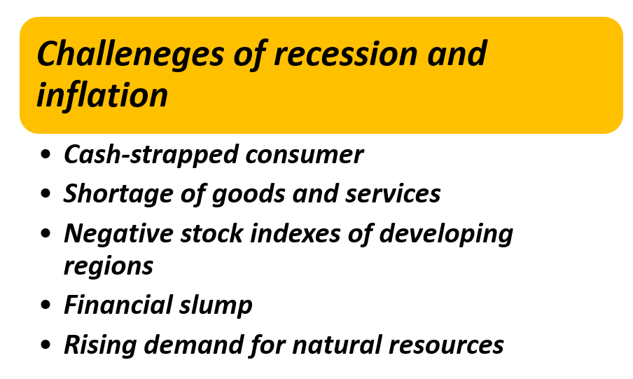

#### Figure 5: Challenges of recession and inflation

## 2.6 Understanding of the causes behind the identified challenges from the patterns of recession and inflation

The pandemic has created enormous issues that are similar to those linked with recession and inflation, but with distinct characteristics. According to Nicola et al. (2020), the pandemic has resulted in severe work reductions, across numerous sectors such as hospitality, tourism leading to recession. Employment declines are a recurrent of both economic recessions and pandemics, as social distancing measures and travel restrictions impair economic activity causing recession during the pandemic. Furthermore, it has been emphasised that while demand for some sectors have declined, demand for other necessary commodities, such as medical supplies and food products has increased. This dynamically represents the changes in consumer behaviour and market demand that occurred during the times of economic insecurity causing the recession.

The interwoven concerns of Brexit, COVID-19 and their interconnected consequences have dramatically affected the economic landscape of the UK. Gupta et al. (2023) highlights the substantial disruptions produced by Brexit and the pandemic, which have caused uncertainty and instability in a variety of economic sectors. The GDP index, which shows changes in economic performance, is one of the significant components investigated. The findings showed that the GDP index rose until 2020 before declining over the COVID-19 era. This finding is consistent with a wider nation that economic stability and inflation are inextricably intertwined. GDP contraction implies a larger economic consequence, including possible inflationary pressures (Gupta et al., 2023). Additionally, the study addresses the effect of trade, indicating that it has declined significantly as a result of both Brexit and the pandemic. This drop in trade can further contribute to inflationary concerns, as interruptions in the supply chain and trade links frequently result in price swings in a variety of commodities.

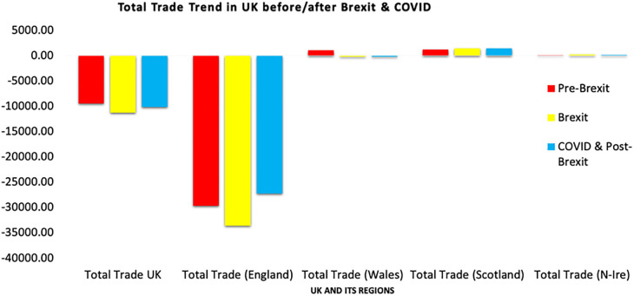

#### Figure 6: Total trade trend in the UK before and after Brexit and COVID

(Source: Gupta et al., 2023)

## 2.7 Analysis of existing strategies used to mitigate the issues related to recession and inflation

The global monetary crisis that erupted in the 1980s, 1990s and 2007 posed significant challenges for national and international policymakers. As per the viewpoint of Boeckx and Cordemans (2017), central banks in developed (the United Kingdom, the United States, Germany, and more) and developing nations (like Brazil, China, India, and more) have heavily relied on their existing ingenuity and imagination in order to restore the financial stability. This has helped the national economy to be stable, which allowed it to tackle recession along with helping in satisfying their mandates. According to Tomaskovic-Devey and Lin (2011), these central banks have reacted swiftly in the crisis management role by providing small business loans, reducing interest and rates on capital, alongside government authorities. Boeckx and Cordemans (2017) also stated that monetary policy in the recession and post-recession period has been geared toward “medium-term price stability”, which helped in achieving neutrality of money along with excess economic costs formulated due to inflation or deflation. The implemented medium-term approach is justified by the “time-lag monetary policy” that has helped in reducing the volatility of economic activity. Funding problem was a crucial aspect of the monetary issue due to high inflation during the recession and inflation period. Therefore, to eliminate funding issues and credit crunch during recessions, central banks endeavoured to accommodate the liquidity needs through performing to full their functionality as the role of lenders. As a result, through the deployment of the medium-term price stability policy, the elimination of liquidity shortage as well as acceptance of deposits from financial institutes in surplus has been eliminated. ***Figure 4*** demonstrates the facts.

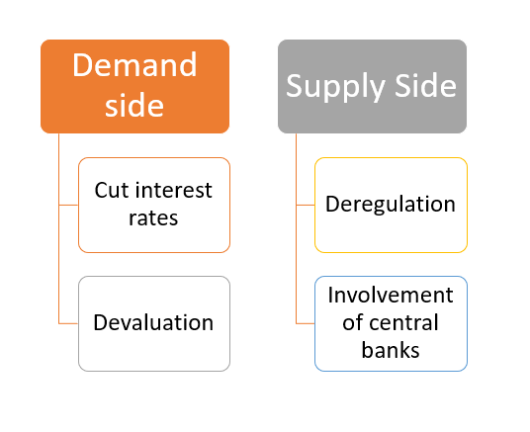

#### Figure 7: Policies for tackling recession

As per the viewpoint of Coibion et al. (2020), onset of the Great Recession occurred in 2007 and constraints imposed due to the implementation of Zero-Lower bound (ZIB) on monetary interest rates have infused non-conventional strategies to the forefront of policy-making. According to Coibion et al. (2020), within the context of recession in the 1990s and 2007, quantitative easing policy along with the forward guidance related to the path of “future interest rates” has emerged as the main monetary policy tool for tackling inflation. The policy is based on different expectational channels like adopting GDP-level targets and raising inflation rates. According to Costa Junior, Garcia-Cintado and Marques Junior (2021) and Coibion et al. (2020), higher expected inflation has the compatibility to lead business firms to dynamically raise the price bar to make the anticipation of rapidly deteriorating relative prices. Hence, fulfilment of the inflation expectations of monetary agents was utilised for the stabilisation of economic conditions.

## 2.8 Theoretical underpinning

***Modern monetary theory (MMT)***

***Definition:***

Within the context of macroeconomic heterodox, modern monetary theory (MMT) recontextualizes the role of fiscal and monetary policy in the sovereign government having issues like national debt and borrowing (Drumetz and Pfister, 2021). According to Prinz and Beck (2021), MMT challenges standard economic assumptions. The challenge is made on the basis of the argument that sovereign governments, who control their currency, have the accessibility to spend freely without being bound by conventional fiscal and monetary restrictions. MMT contends that governments can create new money to meet their financial responsibilities, in contrast to the notion that spending needs to be paid for via taxes or borrowing. The concept of modern monetary theory states that there is a direct association between government interventions and activities of private firms. [***Refer to Figure 8***]

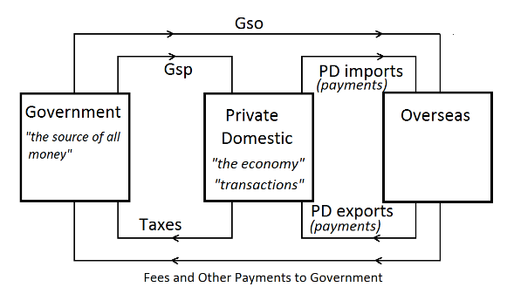

***Figure 8: Modern Monetary Theory***

(Source: Drumetz and Pfister, 2021)

***Application:***

Instead of concentrating only on fiscal or monetary restrictions, MMT promotes a policy approach that emphasises the significance of managing unemployment and inflation (Prinz and Beck, 2021). Governments that adhere to MMT principles have the accessibility to raise spending to bolster the economy, particularly during recessions or times of high unemployment.

***Implication:***

The significant implications of MMT demonstrate that governments have more fiscal leeway than is generally believed. As per the viewpoint of Chohan (2020), MMT proponents contend that in order to attain full employment and economic stability, policymakers need to pay attention to social and economic problems. On the other hand, there exists a scope of raising questions about the longevity of ongoing deficit spending as well as the possibility of inflationary pressures.

***Keynesian Economics Theory***

***Definition:***

Keynesian Economics Theory emphasises the role of government intervention in the economy to assess the fluctuations in aggregate demand (Corrado Benassi, Chirco and Colombo, 1995). According to Otaki (2015), it argues that during economic downturns, the government needs to increase spending and decrease taxes to stimulate demand.

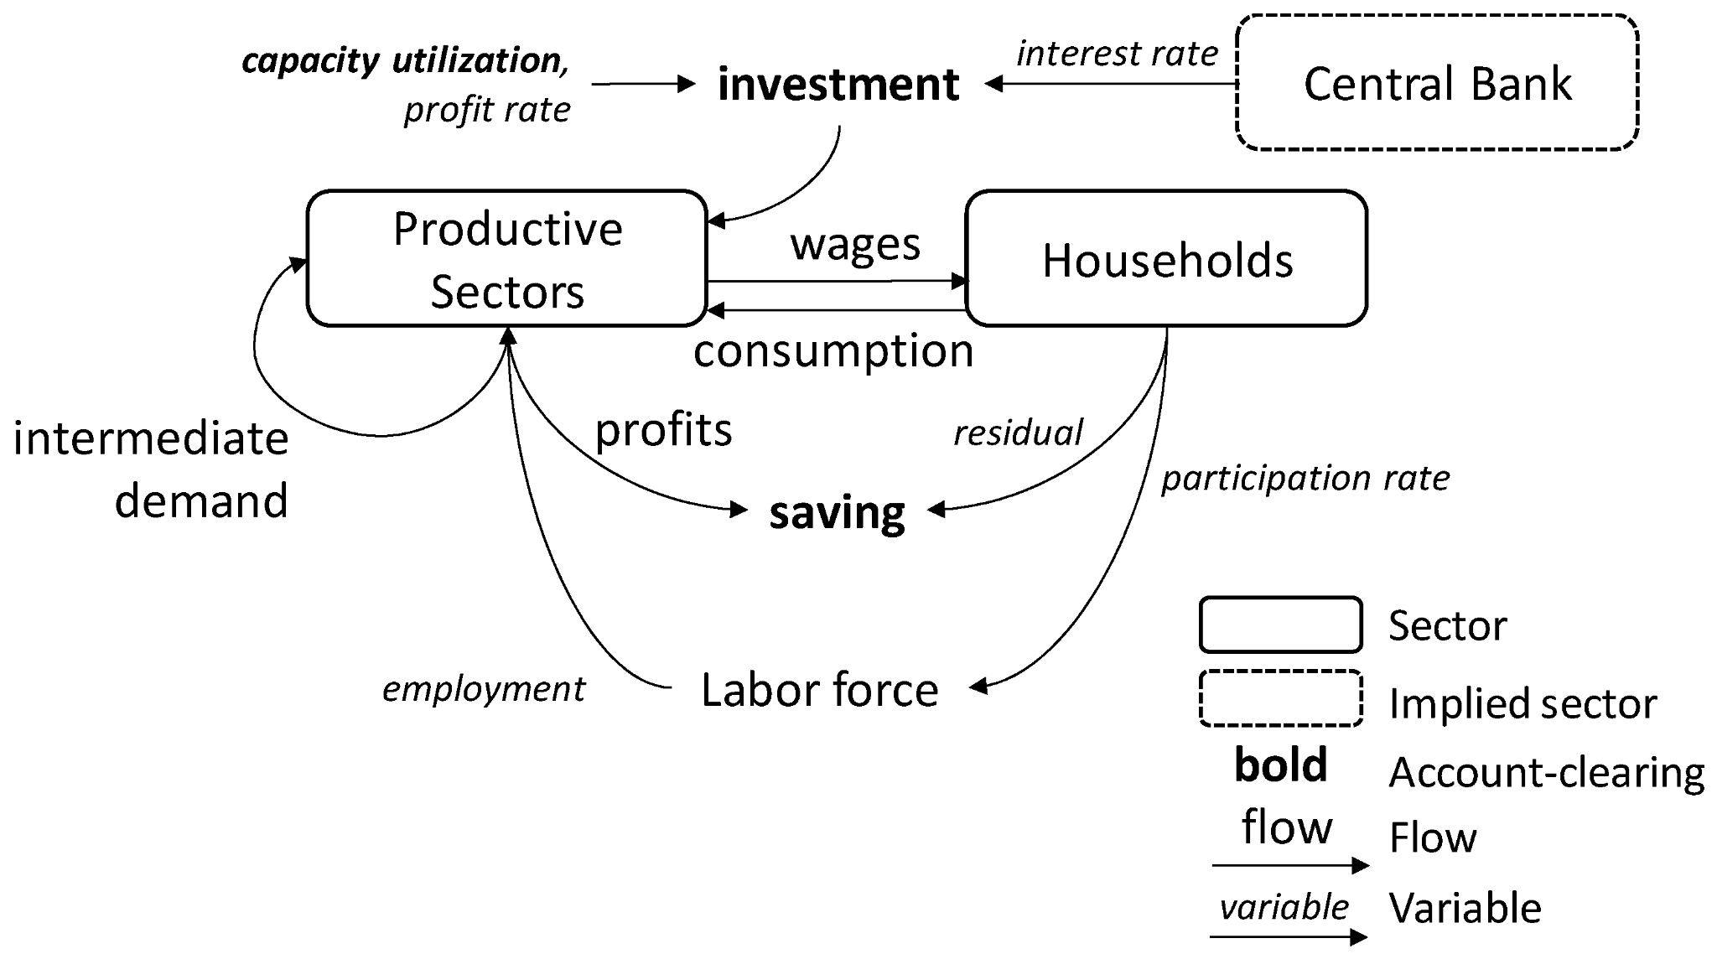

***Figure 9: Concept of Keynesian Economics Theory***

(Source: Kemp-Benedict and Ghosh, 2017)

***Application:***

According to the concept of Keynesian Economics Theory, the government can implement fiscal measures like tax cuts and infrastructure spending in order to stimulate consumer spending and business investment (Tily, 2016). The integration of these interventions has the compatibility to mitigate unemployment and stabilise the economy.

***Implication:***

During economic downturns, the government needs to execute a deficit to support demand in counter-cyclical policies. Therefore, transparency in fiscal and monetary policy gets increased through the deployment of the concept of Keynesian Economics.

## 2.9 Literature gap

In previous research, there have been discussions on global recession and inflation patterns which have been linked with the global economic and financial instability. However, there is limited research available regarding recession and inflation and its link between economic stability of the UK (Matysiak, Sobotka and Vignoli, 2020). Moreover, there is limited study regarding the pattern of recession and inflation on the inclusion of the financial stability aspect. A large number of research efforts have merely concentrated on the analysis and portrayal of numerical information due to the inadequate awareness of implications (Tabash et al., 2022). In order to fill in the gaps and examine the primary consequences the present study has focused on linkage between inflation and recession and financial stability in the UK.

## 2.10 Conceptual Framework

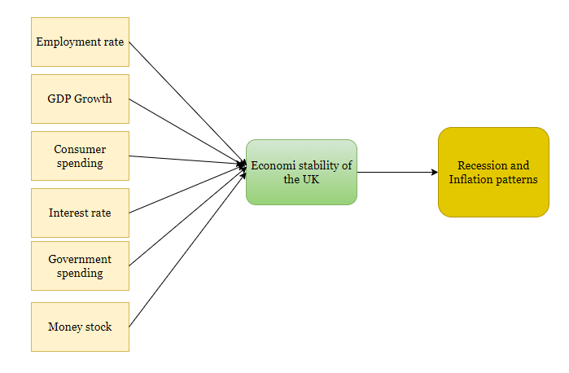

#### Figure 10: Conceptual framework

## 2.11 Summary

This section delves into the intricate patterns and causes of recession and inflation, emphasising the multifaceted nature along with interconnectedness. It explores the effects on the financial stability of countries, employment rates as well as challenges associated with economic stability with recession and inflation. In addition, it also examines the significant strategies employed to mitigate recession as well as inflation-related issues. Theoretical underpinnings such as ***Modern Monetary Theory (MMT)*** and ***Keynesian Economics theory*** are also discussed to understand the entire context adequately. The deployment of the medium-term price stability policy has helped in the elimination of liquidity shortage as well as the acceptance of deposits from financial institutes in surplus. On the basis of the gaps identified further study is to be conducted for further establishment of robust inferences.

# Chapter 3: Methodology

## 3.1 Introduction

This chapter focuses on the methodology employed to execute this research. Methodology is considered as one of the most crucial aspects of any research study as it provides an outline of the approach design, and strategy used to gather and analyse data. The philosophical underpinnings that guide the research are observed through the justifications provided. Therefore, this chapter aims to clarify the methodological choices to pursue a comprehensive understanding of inflation and recession patterns in the UK.

## 3.2 Research Design

Due to the complex nature and the diverse character of the research issue, which centres around inflation and recession patterns in the UK, the adoption of a ***descriptive research design*** for this study is appropriate. Descriptive research aims to offer an accurate representation of the phenomena being studied (Aggarwal and Ranganathan, 2019). This approach is proper since it permits a methodical investigation of the subject without prior presumptions, making it particularly feasible for a thorough knowledge on economic phenomena (Siedlecki, 2020). Inflation and recession are dynamic processes driven by different causes and their results can change across historical periods and economic circumstances (BBC, 2023). In this case, the goal of the study is to characterise and comprehend the patterns and effects of inflation and recession in the UK economic environment. As the economic landscape changes, descriptive research gives the adaptability needed to adjust new trends and patterns, making it a reasonable decision for this research.

## 3.3 Research Approach

The ***deductive research approach*** was chosen for this study because of the requirement for a systematic and hypothesis-driven investigation of UK inflation and recession patterns. Since the deductive methodology considers the development of specific hypotheses in light of existing theories and models, it was more acceptable (Azungah, 2018). The research has systematically considered this assumption in contrast to the actual evidence utilising deductive thinking, and ensuring an exhaustive and logical examination. Furthermore, the deductive approach is consistent with the research purpose of drawing relevant and generalisable findings regarding the patterns and effects of inflation and recession in the UK. The study can contribute to the existing body of economic knowledge and give insights that are anchored on recognised economic theories by using a deductive approach.

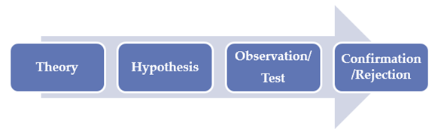

#### Figure 11: Deductive approach

## 3.4 Research Strategy

***Secondary quantitative strategy*** has been chosen for this research given the main focus on analysing the historical patterns inflation and recession in the UK. Firstly, the study intends to investigate long-term economic trends, making quantitative data a valuable source. Secondary quantitative data has provided access to past economic indicators, government reports and statistical records covering long term periods. Secondly, the quantitative method is consistent with deductive research design and hypothesis testing (Gilgun, 2019). It allowed to conduct quantitative analysis using the machine learning algorithm (LSTM) on the hypotheses generated from the existing economic theories against historical facts. Lastly, the utilisation of secondary quantitative data enabled a complete and large-scale examination of the economic environment of the UK. Thus, making this strategy more suitable for this research.

## 3.5 Research Choice

***Mono-quantitative research*** focuses exclusively on quantitative data, which is specifically appropriate for this study since it focuses on analysing historical data related to inflation and recession in the UK. The fundamental purpose of the study is to uncover and comprehend numerical patterns, trends and correlations within economic data to identify current and future inflation and recession occurrences, making the mono-quantitative the most suitable option for this research. This research choice is also in line with the deductive approach where hypotheses are framed derived from economic theories, allowing the testing of the hypothesis through a data-driven approach. Furthermore, the mono-quantitative strategy has the benefit of producing quantifiable and measurable results, which improves the empirical validity of the research (Strijker, Bosworth and Bouter, 2020). Thus, it enabled the discovery of connections, trends and patterns that led to a thorough knowledge of inflation and recession in the UK.

## 3.6 Requirements

The functional requirements of this research include data gathering and analysis that are critical for understanding the complexities of inflation and recession in the UK. A secondary quantitative data collection strategy has been used to effectively satisfy the research objectives. The data sources chosen for collecting are renowned websites, ensuring the reliability and accuracy of the data. Data was gathered from a variety of sources, including the ***International Monetary Fund (IMF)***, which gives important information on major economic indicators such as inflation, GDP growth, government debt and government spending (International Monetary Fund, 2023a). This data spans several years starting from 1980 to 2022, allowing for a detailed examination of long term patterns of the UK economic performance related to inflation and recession.

Furthermore, data from ***MacroTrends*** has been obtained focusing on consumer purchasing trends. This source has been useful in assessing the influence of recession on consumer behaviour, which is an important segment reflecting economic downturns (Macrotrends, 2022). The ***Office for National Statistics (ONS)*** has provided statistics about the labour market in response to economic changes in the UK (ONS, 2019). Data related to employment rates has been a critical component for evaluating the effects of the crisis on labour markets. Data from the ***Bank of England*** about interest rates have been collected to understand the influence of monetary policies across the periods of inflation and recession in the UK whereas the data on money stocks has also been collected from ***ONS*** (Bank of England, 2023; ONS, 2021). This data has assisted in determining how changes in interest rate influence the overall economy.

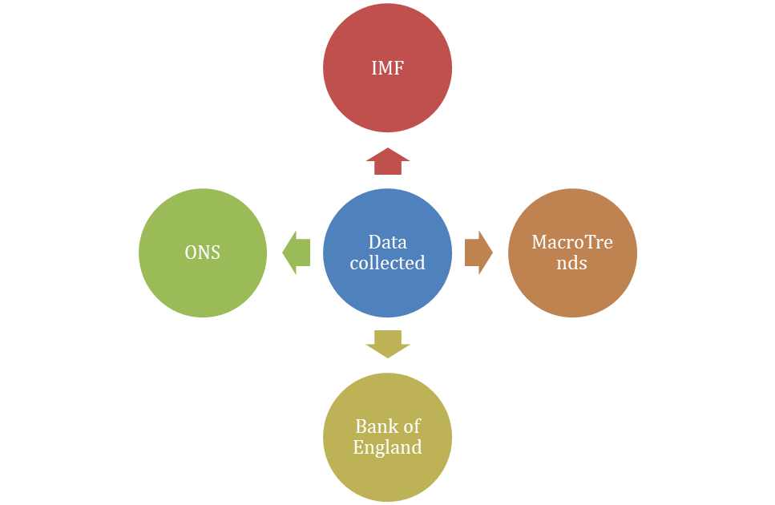

#### Figure 12: Data collection sources

The data analysis strategy incorporates the use of a ***long short term memory or LSTM model***. LSTM is a form of ***Recurrent Neural Network (RNN)*** that works well with time series data (Sherstinsky, 2020). The LSTM model has been used in the study to discover and analyse trends and patterns in inflation and recession data obtained from the aforementioned sources. The use of LSTM allows for the creation of prediction models and the extraction of important insights from the data.

## 3.7 Possible Solution

The projected outcomes of the study are complex and promise to make a significant commitment to the domain of economic research. The research endeavours to provide a detailed study on the circumstances and effects of recession and inflation by diving into the subtle patterns and elements of these economic occasions as identified by Kose, Sugawara and Terrones (2020). It is expected to focus on present and prospective measures for limiting the negative results of recession and inflation, providing policy makers and stakeholders with vital suggestions. Moreover, the findings of the study are expected to uncover the link of recession and inflation and financial soundness of the UK, which can motivate actions to fortify economic resilience and security (Desalegn, Tangl and Fekete-Farkas, 2022). The outcomes are additionally expected to demonstrate the effect of economic occasions like inflation and recession on employment rates. As a result, the research might distinguish and categorise economic stability concerns, permitting strategic planning and risk management.

## 3.8 Implementation

The implementation phase of this research involves the use of ***Python***, a flexible programming language and the use of ***LSTM models*** to analyse and comprehend the trends and patterns of inflation and recession in the UK. Python has been chosen for its adaptability, extensive libraries and robust data analytics capabilities (Raschka, Patterson and Nolet, 2020). It provides a conducive environment for dealing with financial and economic data. The implementation of the research is based on a set of python libraries and tools for in-depth analysis. ***Pandas*** for data processing, ***Numpy*** for numerical operations and ***Matplotlib*** with Seaborn for data visualisation are the key libraries used in this research. ***Scikit-learn*** has been used to help with data preparation, such as splitting and scaling. ***TensorFlow***, an open source machine learning framework, has been used to construct the LSTM models. Since, LSTM is especially designed for dealing with sequence data, it is perfect for analysing economic time series (Le et al., 2019). This configuration has enabled the research to minutely analyse economic data, derive insights and anticipate trends in the context of inflation and recession in the UK.

The LSTM model handles the time series data, incorporating both short term and long term dependencies. This allows for the detection of complicated correlations and patterns that would not have been possible using conventional statistical approaches (Houdt, Mosquera and Nápoles, 2020). The data obtained covers a long period of time starting from 1980 to 2022, allowing for a detailed digital examination of trends and patterns in the UK. Processing time series data to ensure compliance with the LSTM model includes managing missing data, scaling and separating into training and testing datasets. This data preparation has been necessary to guarantee that the model captures inflation and recession trends accurately and effectively. The LSTM model has been then trained on the provided data to recognise and forecast trends in economic indicators, allowing possible variables influencing inflation and recession to be identified.

## 3.9 Test Schedule

|  |  |  |  |  |  |  |  |  |  |  |  |  |
| --- | --- | --- | --- | --- | --- | --- | --- | --- | --- | --- | --- | --- |
|  | ***Week 1*** | ***Week 2*** | ***Week 3*** | ***Week 4*** | ***Week 5*** | ***Week 6*** | ***Week 6*** | ***Week 7*** | ***Week 8*** | ***Week 9*** | ***Week 10*** | ***Week 11-12*** |
| **Background and reading** |  |  |  |  |  |  |  |  |  |  |  |  |
| **Proposal/initial meetings** |  |  |  |  |  |  |  |  |  |  |  |  |
| **Literature review** |  |  |  |  |  |  |  |  |  |  |  |  |
| **Research method planning** |  |  |  |  |  |  |  |  |  |  |  |  |
| **Data collection** |  |  |  |  |  |  |  |  |  |  |  |  |
| **Check on progress/data analysis** |  |  |  |  |  |  |  |  |  |  |  |  |
| **Submit some draft work** |  |  |  |  |  |  |  |  |  |  |  |  |
| **Discuss conclusions** |  |  |  |  |  |  |  |  |  |  |  |  |
| **Future drafts** |  |  |  |  |  |  |  |  |  |  |  |  |
| **Final meeting** |  |  |  |  |  |  |  |  |  |  |  |  |
| **Final draft** |  |  |  |  |  |  |  |  |  |  |  |  |
| **Final submission** |  |  |  |  |  |  |  |  |  |  |  |  |

##### Table 2: Timeline of the proposed study

## 3.10 Chapter Summary

In conclusion, the chapter summarises the reason behind choosing the methods and approaches for conducting this research and how the data has been collected. The chapter also discusses the intended outcomes and the implementation method, emphasising the application of the Python and LSTM model for data analysis. Consequently, this section fills in as the methodological underpinning of the research study, looking to give significant insights into the complicated economic phenomena of inflation and recession in the UK.

# 

# Chapter 4: Results

## 4.1 Introduction

This chapter represents the outcomes of an in-depth analysis of recession and inflation in the UK with a significant focus on key economic indicators such as GDP growth, employment rate, debt, interest rate, and money stock from 1980 to 2022. This chapter also involves the outcomes of Long Short-Term Memory (LSTM) models developed for both recession and inflation. Additionally, it provides visual analyses to illustrate the patterns and trends in these economic phenomena, contributing insights into the interplay and effect on the financial landscape of the UK. The accuracy scores along with model summaries of the LSTM models offer a comprehensive understanding of the economic dynamic in the UK.

## 4.2 Analysis

### 4.2.1 Factors stipulating recession in the UK

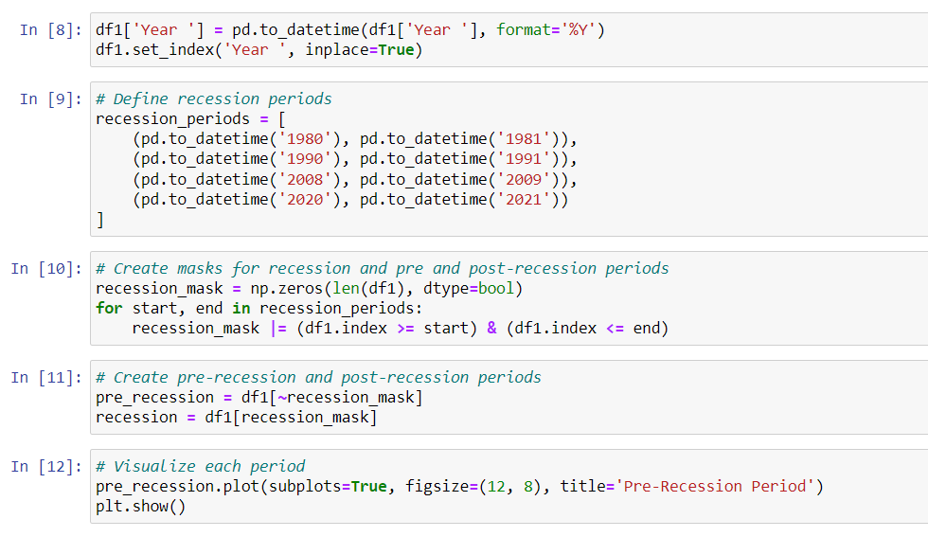

#### Figure 13: Recession and non-recession period

During the recession, GDP of the nation fell due to a degradation in income level, consumer spending and money stocks. On the other hand, national debt increased due to the recession, leading to a negative consequence for the economic stability of the nation. In the UK, during 1980-1981, the earnings of UK-based companies declined by 35%, the employment rate declined by 5.3% and the GDP growth rate also degraded by approximately 11.9% (IMF, 2023; Macrotrends, 2022; ONS, 2019). During 1990-1991, company earnings were reduced by 25% and the employment rate declined by 6.9% (IMF, 2023; Macrotrends, 2022; ONS, 2019). The Great Recession occurred in the UK in 2008-2009 due to increasing global commodity prices and credit crunch. Due to this, data collected on different economic metrics such as consumer spending, money stock, debt, GDP and employment rate have been segmented into three categories, which are pre-recession, recession, and post-recession [***Refer to Figure 13***]. The use of the masking method has helped in the segregation of pre-recession and post-recession periods. Pandas’ library has been used for masking the time series (years).

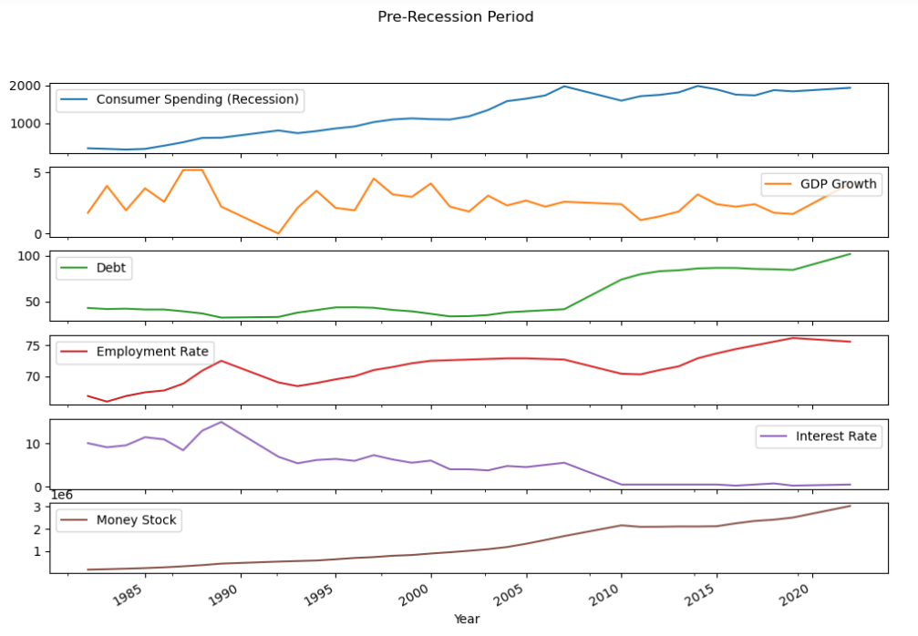

#### Figure 14: Consumer spending, debt, employment rate, interest rate and money stocks in the pre-recession period

(Source: IMF, 2023; Macrotrends, 2022; ONS, 2019)

From ***Figure 14*** it can be observed that consumer spending declined during 2008-2009, while the national debt increased significantly. The money stock also increased during the period. As a result, GDP growth declined by more than 6.5% during 2008-2009 in the UK (Wearden, 2009). The quarterly employment rate declined by more than 8.4% in 2009, and the unemployment rate reached its peak during the Great Recession in the UK (Office for National Statistics, 2018). On the other hand, from 1985 to 1989 (pre-recission period), the employment rate in the UK reached its peak (75%) and the GDP growth rate increased by more than 5% during this period (Wearden, 2009). This indicates that national stability was significantly higher in the UK during 1985-1989.

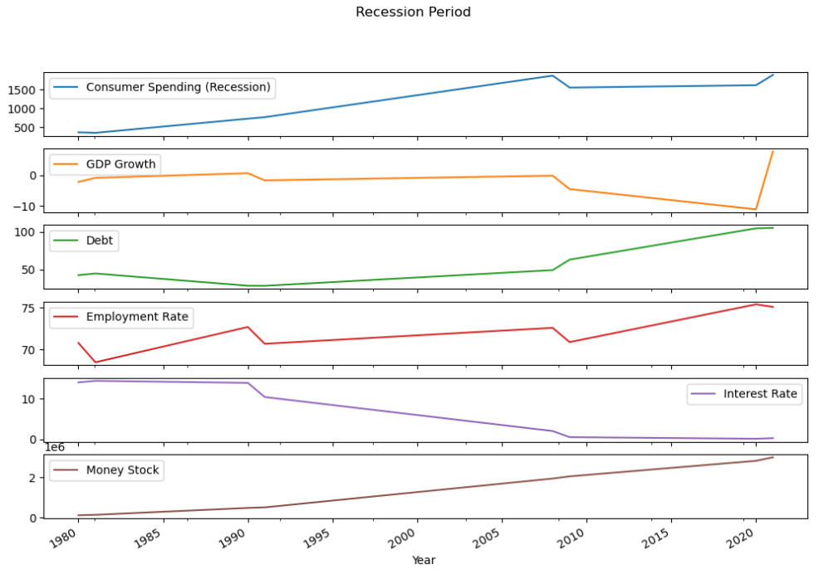

#### Figure 15: Consumer spending, debt, employment rate, interest rate and money stocks in recession period

(Source: IMF, 2023; Macrotrends, 2022; ONS, 2019; ONS, 2021; Bank of England, 2023)

***Figure 15*** demonstrates the degradation in employment rate, rise in money stocks, rise in national debt, and downfall in GDP growth rate during the recession in the UK. It has been found that debt in 2008 and 2020 was significantly higher in the UK. On the other hand, the employment rate significantly dropped by more than 6% in 2008-2009 due to the occurrence of recession caused by the Global Financial Crisis in the US. During the recession in 2020, the growth of the UK economy was shrunken by approximately 20.4% (King, 2020). It can be stated that there the link between recession and economic growth in the UK is negative.

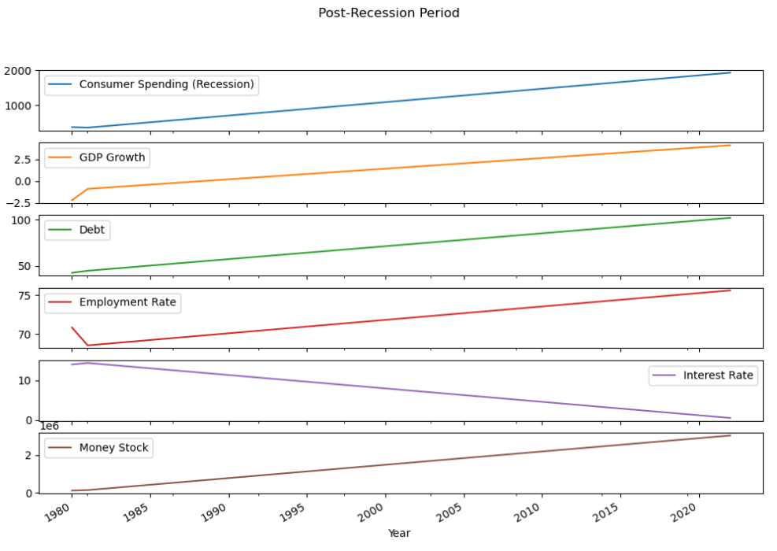

#### Figure 16: Consumer spending, debt, employment rate, interest rate and money stocks in the post-recession period

(Source: IMF, 2023; Macrotrends, 2022; ONS, 2019; ONS, 2021)

In the post-recession period (from 2011-2013), pay freeze and pay capital increased, which kept wage rises below the inflation. From 2015 (November) to 2016 (October), the value of the British pound fell by 20%, which created a negative effect on consumer spending in the UK during the mentioned period thus creating a link with recession (Office for National Statistics, 2018). Policymakers in the UK have put on high alert for the occurrence of a recession after observing a surge in interest rates. This has slumped the factory output by 20% after the recession in 2008 (Elliott, 2023b). In fact, the rate-setting monetary policy raised borrowing costs by approximately 0.25%, which created a negative linkage with consumer spending in the UK in 2010-2012 (Elliott, 2023b). Hence, it can be stated that with the rise in the price of products due to increasing levels of debt, interest rates, and lower GDP growth, consumer spending in the post-recession period is bound to decrease.

### 4.2.2 Factors triggering inflation in the UK

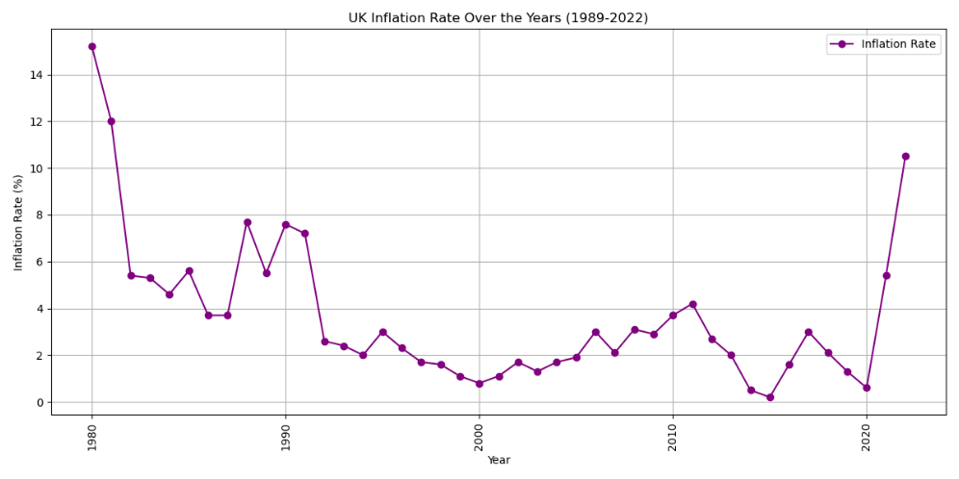

#### Figure 17: UK Inflation rate over the Years

(Source: International Monetary Fund, 2023a)

The line plot of ***Figure 17*** illustrates the inflation rate of the UK from 1989 to 2022, providing a clear visual representation of its trends over the years. The graph depicts fluctuations in the UK inflation rate with peaks and troughs corresponding to economic events and policy changes. Kozlov (2023) has analysed the impact of changes in interest rates on inflation. It has been noted that inflation rates are sensitive to interest rate adjustments and this sensitivity is reflected in the trend of the graph. Similarly, it has been observed that with a rise in the prices of fuel and food in the UK, the rate of inflation increased to 10.1% creating a link between inflation and cost of living (Partington, 2022b). It shows how the inflation rate responded to the economic shocks of the 2008 financial crisis and the COVID-19 pandemic.

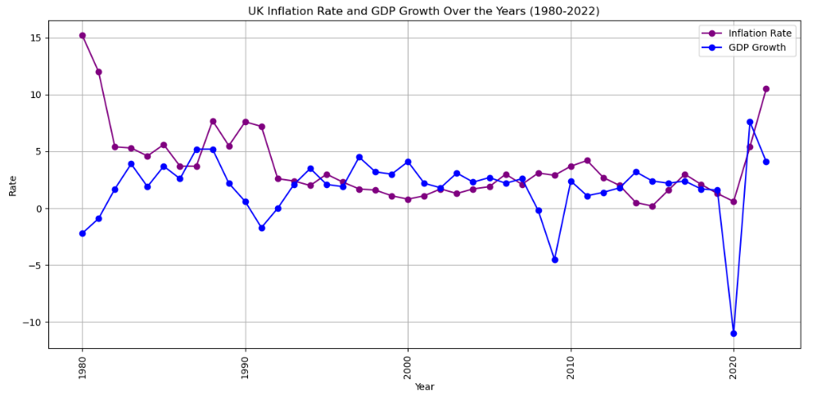

#### Figure 18: UK Inflation Rate and GDP Growth

(Source: International Monetary Fund, 2023a)

The line chart represents the UK inflation rate and GDP growth over the years, exploring an inverse relationship between these two economic indicators. While inflation rises, GDP growth tends to slow down and vice versa. Atigala et al. (2022) have emphasised how high inflation rates can erode consumer purchasing power and lead to decreased economic growth. It has been observed that the UK has been able to recover strongly in 2022 with a GDP of 4.2% after the devastating impact of the Covid-19 pandemic by helping the rate of inflation to stabilise (Partington, 2023a). Moreover, during periods of lower inflation in ***Figure 18***, consumer confidence tends to increase, spurring spending and contributing to higher GDP growth.

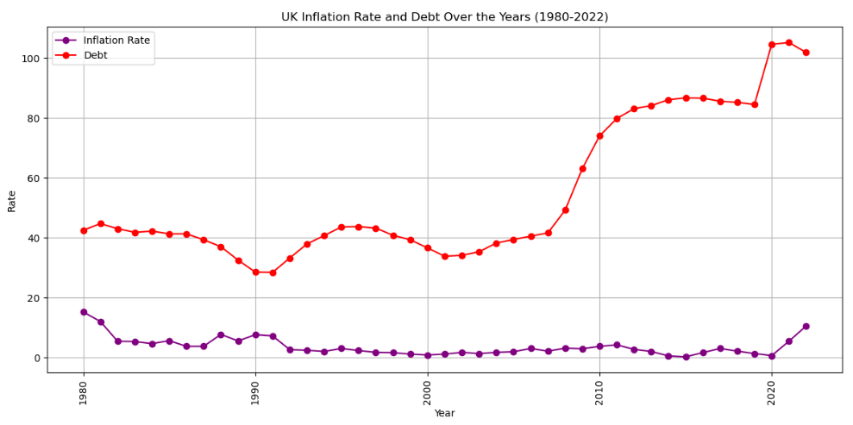

#### Figure 19: UK Inflation rate and Debt over the years

(Source: International Monetary Fund, 2023a)

The graphical representation depicting the UK inflation rate and national debt from 1980 to 2022 illustrates a notable connection between these two economic variables. As inflation increases, the national debt tends to rise, and when inflation is lower, the debt growth rate slows down. Butkus and Seputiene (2018) have highlighted the linkage of inflation with debt dynamics with an argument that cost of serving debt can increase the inflation, thus generating linkage between debt and inflation. According to Elliott (2023a), the IMF has stated that the public debt of the UK is expected to increase in the coming 5 years which can affect the rate of inflation in the country. Thus, fluctuations in ***Figure 19*** underline the necessity of maintaining a balance between managing inflation and growth of debt for overall economic stability.

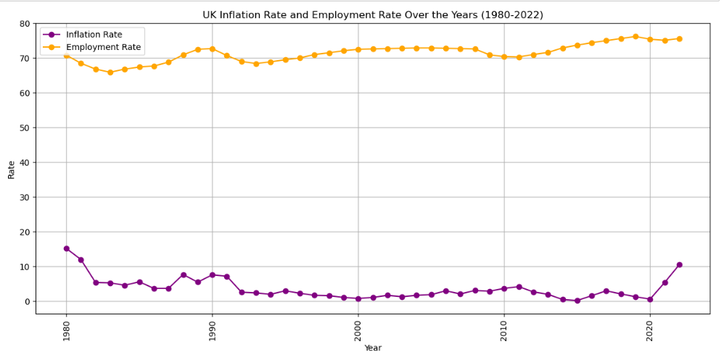

#### Figure 20: UK Inflation rate and Employment Rate

(Source: ONS, 2019; International Monetary Fund, 2023a)

The above visual representation shows the inflation rate and employment rate from 1980 to 2022 which exhibits a direct relationship. As inflation increases, the employment rate tends to increase. This aligns with the findings of a study by Camara, Ouedraogo, and Sy (2023), which emphasised that high inflation could reduce consumer purchasing power resulting in higher unemployment rates. The UK labour market has been able to implement strategies that helped in increasing the wage rate allowing employment to increase despite high inflation (Strauss, 2023). Thus, the fluctuations in ***Figure 20*** underscore the significance of managing inflation to support employment stability in the UK.

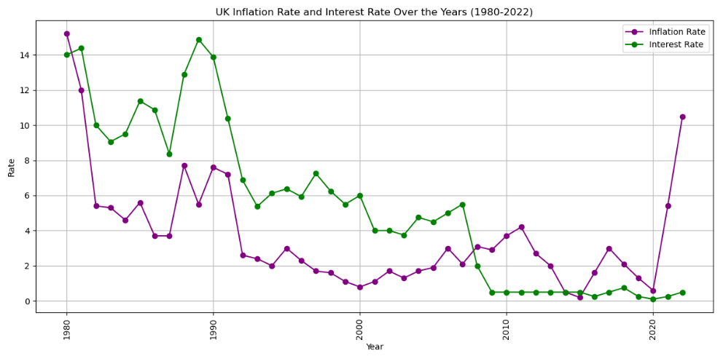

#### Figure 21: UK Inflation Rate and Interest Rate

(Source: Bank of England, 2023; International Monetary Fund, 2023a)

The chart showcases the relationship between the Inflation rate of the UK and the Interest rate over the years, contributing a positive correlation. As inflation rises, interest rates tend to rise and while inflation falls, interest rates decline. Camara, Ouedraogo, and Sy (2023) have indicated that central banks typically respond to inflation by raising interest rates to curb price growth. Likewise, Inman (2022), stated that with a rise of the interest rate to 3.5% by the Bank of England to cope with the recession, the rate of inflation might increase as well as loans would become costly. Therefore, these fluctuations in ***Figure 21*** reflect monetary policy measures taken by the Central Bank of the UK to control inflation levels over the years.

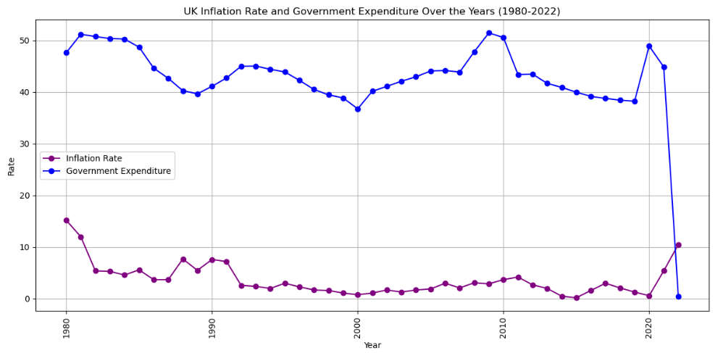

#### Figure 22: UK Inflation rate and Government Expenditure

(Source: International Monetary Fund, 2023a)

The graphical representation illustrating the UK inflation rate and Government expenditure from 1980 to 2022 showcases an interesting relationship. There appears to be an inverse correlation between the two. While government expenditure increases, inflation tends to decrease and vice versa. This specific pattern is consistent with research by Jørgensen and Ravn (2022), which suggests that an increase in government spending can have a dampening effect on inflation. ***Figure 22*** involves fluctuations that reflect the fiscal policies adopted by the UK government over the years to manage inflation while stimulating economic growth.

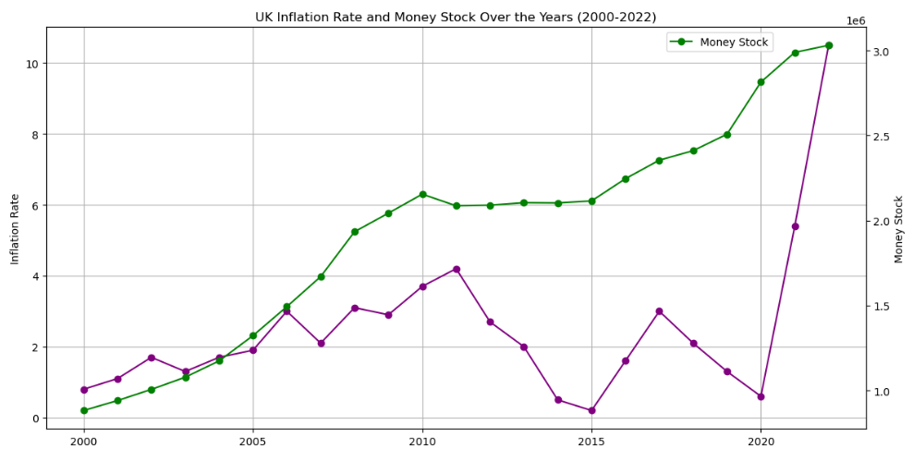

#### Figure 23: UK Inflation Rate and Money Stock

(Source: ONS, 2021; International Monetary Fund, 2023a)

***Figure 23*** shows the UK inflation rate and money stock graph from 1980 to 2022 which reflects a notable relationship. There seems to be a positive correlation between the two variables. While money stock increases, inflation tends to rise, and conversely, while money stock decreases inflation decreases. Trinh (2022) has discussed the quantity theory of money as described in the theory developed by Friedman. According to the theory, an increase in the money supply typically leads to higher inflation. The fluctuations in this chart reflect changes in monetary policy and the entire money supply management in the UK.

## 4.3 Contribution of Machine Learning Model to Predict Recession and Inflation in the UK

### 4.3.1 LSTM Model for interpreting aspects catering recession in the UK overtime

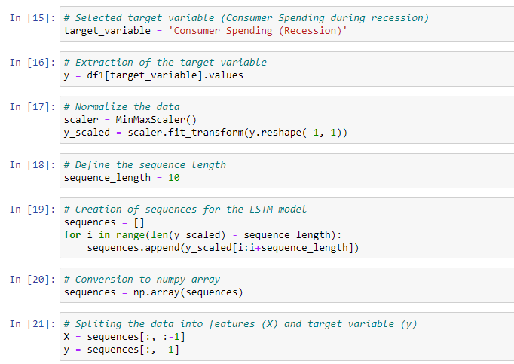

#### Figure 24: Selection of target variables and normalisation

Consumer Spending (Recession)has been selected as the target variable for measuring the factors affecting recession in the UK. Normalisation of data has been performed using ‘MinMaxScalar’ with a sequence length of 10.

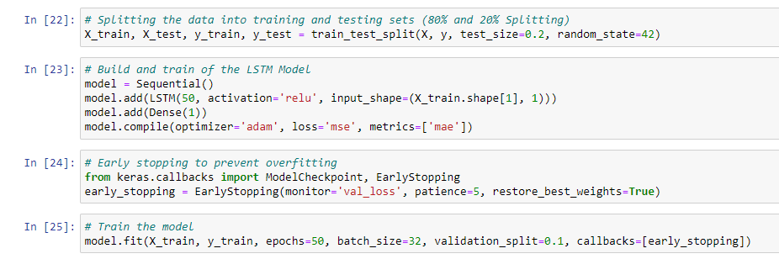

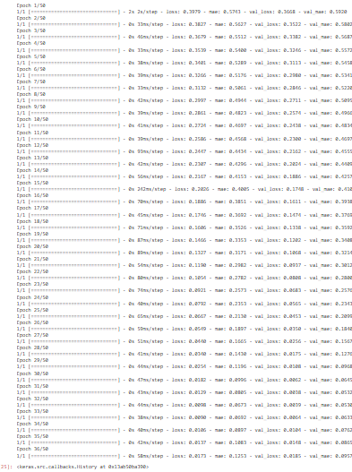

#### Figure 25: MAE and loss of the LSTM Model for Recession

***Figure 25*** demonstrates the development of training of the LSTM model. After the completion of 50 epochs with a batch size of 32, it has been found that the loss of the model is 0.0173 and the mean absolute error is 0.1253 or 12.53%.

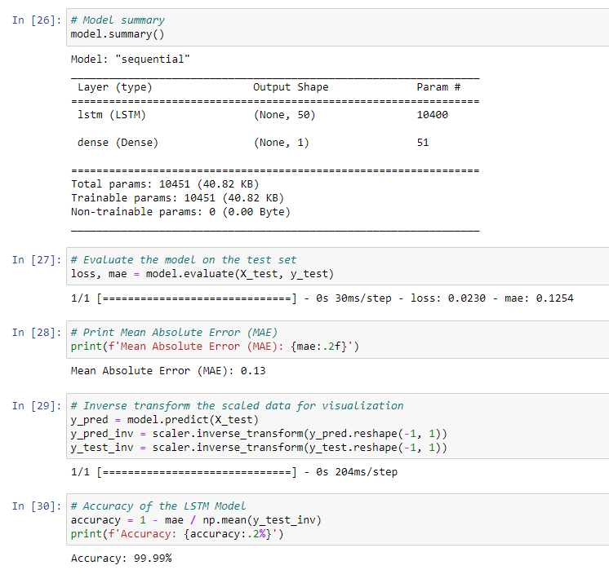

#### Figure 26: Model summary of the LSTM model for Recession

Mean absolute error measures the difference between the actual value and the predicted value. The value of loss and MAE on the test set of recession is 0.023 and 0.1253. The value of the mean absolute error is 0.13 or 13%, indicating that the developed predicted model is highly accurate for the determination of trends and patterns affecting recession in the UK. The obtained accuracy of the LSTM model is 99.99% indicating that the model has been able to properly understand the trend and patterns of recession in the UK.

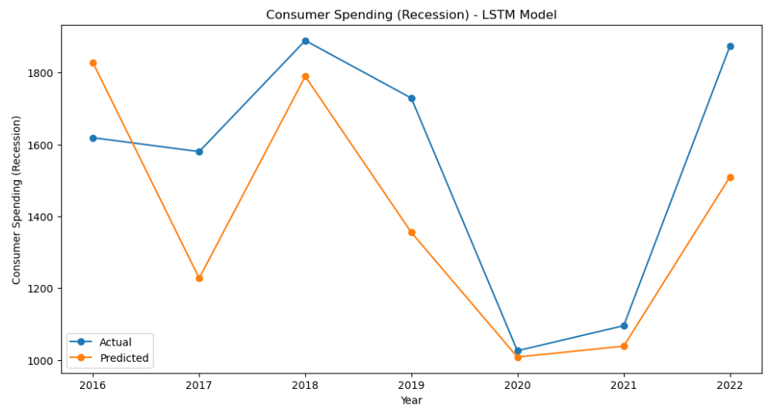

#### Figure 27: Actual and predicted trendline for the recession in the UK

From ***Figure 27***, it can be stated that consumer spending was significantly lowered during the recession in 2020-2021. The economy of the UK shrank by 0.5% in 2021 due to the reduction in consumer spending (King, 2020). The GDP growth rate in 2021, Quarter 1 declined to -.1.1%, showcasing severe degradation in consumer spending (King, 2020). Hence, it can be stated that the predicted trendline has accurately followed the actual trendline of recession in the UK.

### 4.3.2 LSTM model for factorial analysis regarding inflation in the UK

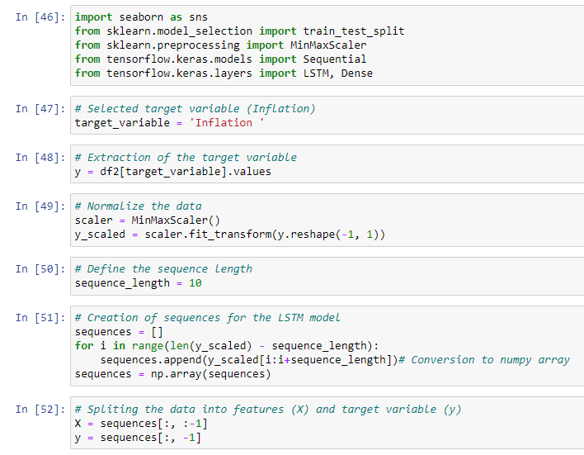

#### Figure 28: Target Variable Selection by defining the sequence length

In the context of building an LSTM model for inflation prediction in the UK, the code begins by preparing the target variable “Inflation”. The inflation data is normalised using MinMaxScaler to ensure that it falls within a specific range. Sequences of data are then created to train the LSTM model with each sequence comprising a specified sequence length, which is essential for time series data. The data is then split into features (X) and the target variable (y) for facilitating model training. The preprocessing steps in ***Figure 28*** are essential for training the LSTM model to understand the trends and patterns of inflation rates in the country depending on historical data.

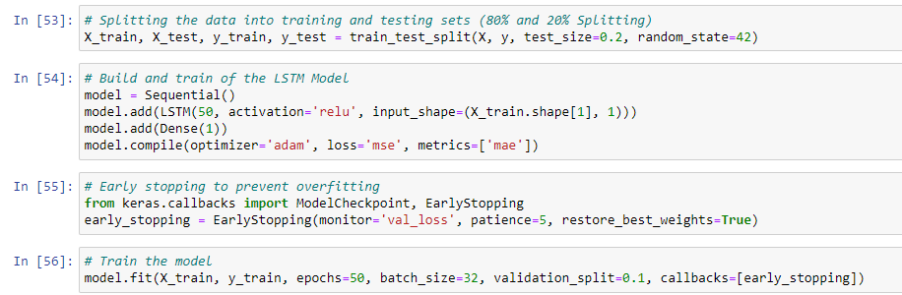

#### Figure 29: Building and Training Process of the LSTM Model

***Figure 29*** mainly involves the data splitting into training and testing sets (80% and 20% respectively), the LSTM model for analysing the trend and pattern of inflation in the UK is constructed, and trained. The model architecture consists of an LSTM layer with 50 units and a ReLU activation function, followed by a dense output layer. It is optimised using Adam optimiser, with MSE as the loss function and MAE as a metric to measure performance. Early stopping with a patience of 5 is implemented to prevent overfitting. The model is then trained for 50 epochs with a batch size of 32, using a portion of the training data for validation. This enables the model to learn and make accurate inflation predictions based on historical sequences.

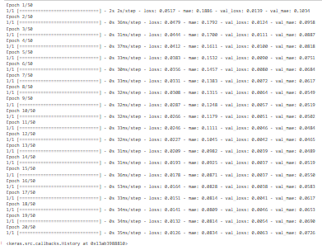

#### Figure 30: Training and Validation Performance of the LSTM model

The figure shows the training and validation performance of the LSTM model for UK inflation trend and pattern analysis. Over 20 epochs, the MSE loss and MAE are displayed indicating the capability of the model. As training progresses, both the training and validation losses decrease, while the MAE provides insight into the accuracy of the model. Early stopping is implemented to explore the optimal point at which validation loss initiates to increase.

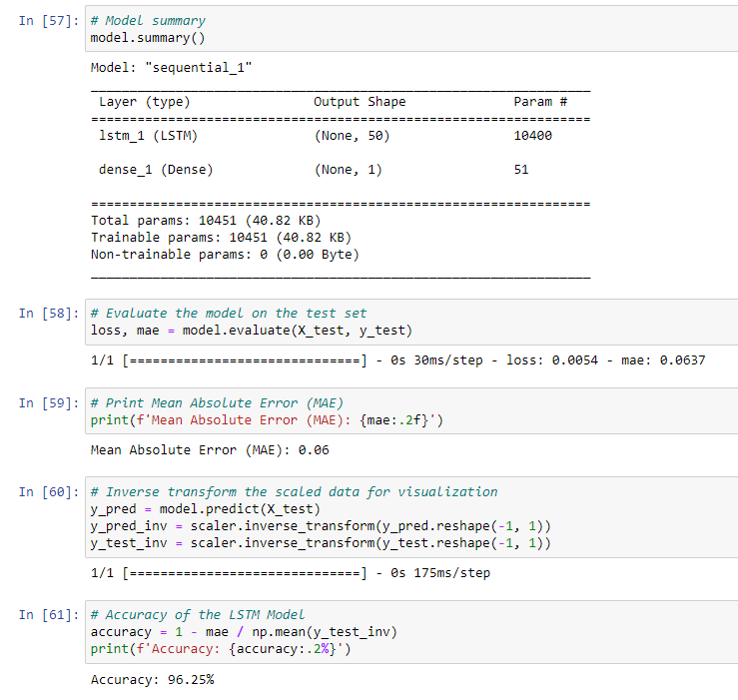

#### Figure 31: Model Summary with an Accuracy Score of the Model

The LSTM model for understanding the trend and pattern of UK inflation performs exceptionally well based on 40-year data. After training, the model is evaluated on the test set, resulting in an MAE of 0.06, indicating its high accuracy in predicting inflation. The accuracy of this model is calculated as 96.25%, suggesting its effectiveness in capturing inflation patterns. Thus, this achievement illustrates the capability of the LSTM model to properly understand the trends and patterns depending on historical data, contributing valuable insights into inflation trends in the UK.

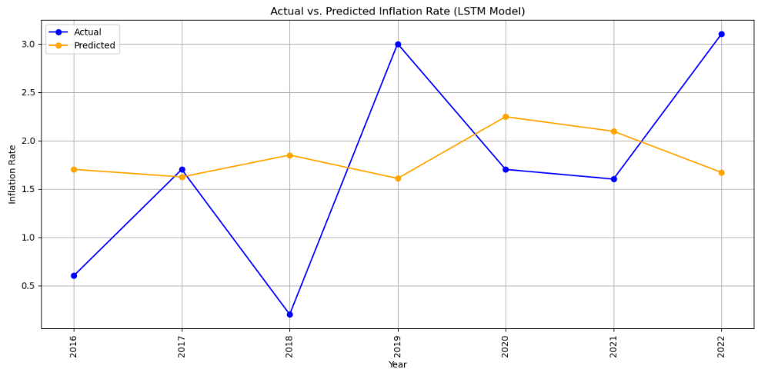

#### Figure 32: Actual vs. Predicted Inflation Rate

The striking resemblance between the actual and predicted inflation rates in the UK, as depicted in ***Figure 32***, implies the robust performance of the LSTM model in capturing short and long-term inflation trends. This indicates that the model identifies as well as adapts to diverse economic factors along with policy changes influencing inflation over the years. This finding also aligns with the insights from the ONS announcement on inflation trends in the UK, in which sophisticated modelling techniques are noted for the capability to mirror actual inflation patterns (Michael and Howard, 2023). It also illustrates the significance of understanding and forecasting inflation accurately.

## 4.4 Visualization Using PBI Dashboard

### 4.4.1 Yearly Recession and Inflation PBI Reports

#### Figure 33: Yearly Inflation and Recession Summary

#### Figure 33: Yearly Recession and Inflation Data Table

#### Figure 35: Yearly Inflation

#### Figure 36: Yearly Recession

### 4.4.2 Monthly CPI, CPIH and GDP Growth PBI Reports

#### Figure 37: Monthly Inflation and Quarterly GDP Growth Summary

#### Figure 38: Monthly Data Table

#### Figure 39: Monthly Consumer Product Inflation

#### Figure 40: Quarterly and Yearly GDP Growth

#### Figure 41: Monthly Household Inflation Summary

## 4.5 Findings

The analysis of the UK recession showed previous occurrences of economic downturns, including the Great Recession of 2008–2009 and the effects of COVID-19 in 2020. Due to the occurrence of recession in 2009, the economy of the UK observed a GDP decrease of to a decline in consumer spending and a huge rise in the debt of the country during the crisis. Wage freezes and currency devaluations throughout the post-recession period had negative linkage with consumer spending. It has been found that the rise in national debt and reduction in consumer spending along with a decline in GDP is the primary reason for the occurrence of recession in the UK. The LSTM models for determining factors of recession and inflation demonstrate high model accuracy, The accuracy of the LSTM model for recession achieved an accuracy of 99.99% and the inflation model achieved an accuracy of 96.25% allowing to properly understand the trends and patterns in recession and inflation.

## 4.6 Chapter Summary

In this chapter, a thorough analysis of recession and inflation in the UK contributes a comprehensive understanding of the economic dynamics that have shaped the nation over diverse decades. Through a series of data-driven visualisations, the linkage of recession and inflation with the economic factors are examined. The complicated relationship between inflation and factors such as interest rates, government expenditure, money stock, and others are also explored in this chapter. It is harnessed with the power of machine learning, specifically the LSTM model to understand the pattern and trend of recession and inflation accurately to achieve remarkable results.

# Chapter 5: Discussion

## 5.1 Introduction

This chapter mainly elaborates a comprehensive discussion on the intricacies of economic stability in the UK by focusing on the patterns in recession and inflation. The functionality of the software analysis is evaluated focusing on the recession and inflation patterns of the UK. Significant aspects such as employment rates and government expenditure are also explored that influence these patterns. The chapter also delves into the challenges associated with economic fluctuations, aiming to identify their underlying causes. Additionally, strategic recommendations are also offered for effectively mitigating the consequences of the patterns of recession and inflation, ensuring a stable economic landscape. This discussion chapter encapsulates the culmination of research efforts, shedding light on diverse key insights along with solutions for economic stability in the UK.

## 5.2 Evaluation of the functionality of the software analysis

The software analysis conducted in this study has played a pivotal role in understanding and evaluating economic stability, especially focusing on recession and inflation patterns in the UK. The analysis encompasses a comprehensive examination of historical data, trends, and diverse influencing factors that contribute to economic fluctuations. In data preprocessing, the pre-recession period involves stable economic data of the UK, while the post-recession period focuses on transforming data during the recovery phase. Additionally handling missing values, and data standardisation for analysis are also essential for meaningful economic trend analysis.

The entire process of visualising all complicated economic data has been one of the most standout features taken into account. The visual representations provided throughout the analysis, contribute a clear and concise overview of key economic indicators, involving GDP growth, debt, employment rate, interest rate, government expenditure, and money stock. These visualisations make the data accessible to diverse stakeholders, including policymakers, the general public, and economists, facilitating a deeper understanding of economic trends. The data processing functionalities, involving data normalisation, feature selection, and defining lengths for time series data have proved indispensable for the performance of the LSTM model.

The LSTM models developed for recession and inflation analysis underscore the proficiency of the software. Achieving remarkable accuracy levels of 99.99% for the recession model and 96.25% for the inflation model, the LSTM model excels in modelling intricate economic trends. These high accuracy rates imply the exceptional ability of the software to capture as well as understand complicated economic patterns in assessing its functionality. The capability of the analysis to discern the causes and consequences of economic events, such as the effect of national debt and consumer spending on recessions and the relationships between inflation, GDP growth, and employment rates and inflation and recession are the fundamental assets for this context. This helps to identify patterns and provides valuable insights into the underlying economic mechanisms.

## 5.3 Exploring economic stability in the UK focusing on the significant patterns of both recession and inflation

The complicated patterns and dynamics of recession and inflation were highlighted by Kose, Sugawara, and Terrones (2020). The study emphasised how these economic events might have a variety of origins and consequences. While recession referred to the major drop in economic activity induced by factors such as lower consumer expenditure and rising unemployment, inflation was blamed on causes such as growing manufacturing prices and changing government policy. The analysis has been built on these concepts by investigating how economic variables such as GDP growth, money stock, public debt, government spending and interest rates are related to recession and inflation trends. Government spending has been found to encourage economic growth, whereas changes in the money supply impact inflation rates. The analysis supported the findings from the empirical studies by examining the experiences of the country during recession. This highlights how global recession occurring at the same time, as well as the challenges they bring for economic stability, demonstrate how interconnected the countries are throughout the world. On the other hand, the analysis also shows inflation in the UK by developing relationships with energy prices and its effects on economic stability. Thus, the importance of exploring recession and inflation patterns to understand the economic stability of the UK can be evaluated from the discussions, thereby discussing the first objective.

## 5.4 Understanding variations in employment rate, GDP Growth, Money Stock, Debt, Government Expenditure and Interest Rate influencing the patterns of recession and inflation

Based on the findings, it has been observed that employment rates are crucial factors ensuring economic stability. According to Panagiotis and Argyrios (2023), higher income might cause a short term increase in employment during inflation. In the long run, however, when purchasing power is eroded by inflation, there is a decrease in willingness to work. In addition, the ML algorithm indicated how employment rates changed during the global financial crisis and its influence on the economic stability of the UK. It was seen that the credit market freeze during the crisis caused a dramatic drop in the global economy, affecting employment showing linkage with inflation and recession. With respect to Keynesian economic theory, Tily (2016) emphasised the significance of government involvement to create demand and mitigate economic downturns. When assessing the GDP in the UK using the LSTM model, the analysis highlighted how the global financial crisis and Brexit had a substantial influence on economic performance. It suggested a link between economic stability and inflation that was not empirically addressed.

Nyasha and Odhiambo (2019) discussed the government expenditure for stimulating economic growth when allocated properly, thus contributing to economic stability. The analysis through ML model reaffirmed this by delving into government spending statistics and its link to various economic indicators, emphasising the significance of correctly allocating government funds. These variations and alignments in the selected components contribute to a thorough understanding of the dynamics of economic stability in the UK, thereby addressing the second research objective.

## 5.5 Challenges associated with patterns of recession and inflation

The analysis of recession and inflation in the UK, supplemented by the LSTM machine learning model has revealed that economic dynamics with respect to different macroeconomic aspects like government debt, money stock and employment are key factors that influence the patterns of recession and inflation. Additionally, findings from existing literature have revealed that declining consumer spending and escalating national debt are the main drivers for the occurrence of recession (Desalegn, Tangl and Fekete-Farkas, 2022; Prohorovs, 2022). In fact, high government expenditure, increasing interest rates and low GDP growth directly affect inflation. Inflation in the UK has further degraded consumer spending, which has further created negative consequences on the growth of the national economy. While the prior empirical studies focused on broad challenges such as geopolitical unrest, natural resources demand and the impact on developing nations, the analysis highlighted the specific events affecting the UK economy such as the 2008 financial crisis and Brexit. Though not entirely focused on currency exchange rates, the analysis does investigate the influence of issues such as trade interruptions, which have an indirect impact on the currency exchange rates. Thus, by evaluating the internal and external events of the UK, the study has addressed the third research objective.

## 5.6 Identification of causes of challenges to demonstrate recession and inflation Fluctuations

Covid-19 pandemic induced severe work fluctuations, which has led to the formulation of recessionary trends in the UK. The dynamic changes in the consumption patterns of consumers due to economic insecurity have reduced the demand for luxury as well as essential commodities (Gupta et al., 2023). From existing literature it has been found that Brexit and the pandemic together have disrupted the different financial sectors in the UK, leading to instability and uncertainty within the national economic growth (Gupta et al., 2023). From the assessment of the LSTM model, it has been found that economic stabilising factors like the national debt, government expenditure, money stocks and the employment rate have a direct association with the occurrence and recovery from recession. According to Victor et al. (2021), rescission weakens the supply-demand equilibrium, which further disturbs economic stability. The lack of collaboration between government authorities and central banks was the main reason for facing difficulties in recovering from recession and inflation thus discussing the fourth objective.

## 5.7 Recommendation for efficient mitigation of inflation and recession

From existing literature it has been found that traditional measures like monetary interventions from central banks and medium-term price stability policies were significant for the post-recession recovery in the UK (Boeckx and Cordemans, 2017; Coibion et al., 2020). The implication of the Zero-lower bound policy was significant for the stabilisation of interest rates and tax evasion. This has played a crucial role in the financial recovery and increasing consumer spending after the Great Recession in the UK in 2007. The strategy was primarily focused on quantitative easing and providing forward guidance for manufacturing firms in the UK. As a result, manufacturing entities in the UK were able to reduce the price of commodities, which has led the consumer to spend more. Therefore, it can be stated that the implication of the Zero-lower bound policy and medium-term price stability policies are effective for normalising financial turmoil in the recession and post-recession period. From the LSTM model, it has been found that money stocks and national debt have an immersive impact on inflation and recession. Therefore, policymakers and government authorities need to focus on stabilising money stocks and minimising national debt to cope with the recession and increasing inflation in the UK thus discussing the fifth objective.

## 5.8 Summary

Based on the above analysis, this chapter mainly comprehensively evaluates the economic stability of the UK, especially concerning recession and inflation patterns. The discussion chapter, mainly driven by extensive historical data examination, highlights the significance of variables such as GDP growth, government expenditure, interest rates, and many more in shaping the economic trends. Diverse challenges associated with recession and inflation in the UK primarily stem from declining consumer spending and increasing national debt with low GDP growth. Challenges tied to recession and inflation were revealed driven by events such as the 2008 crisis, Brexit and the COVID-19 pandemic. Thus, identifying these challenges underscores the requirement for coordinated efforts between government and central banks for effective mitigation strategies.

# Chapter 6: Conclusion and Recommendations

## 6.1 Conclusion

After discussing the research in detail, it can be concluded that the findings from the research have addressed all the objectives of the research. According to the preceding section, recession and inflation are basic economic cycles that are important for exploring the economic health and security of nations. Recession patterns can vary in severity and duration which can bring economic downturns leading to more extended and severe crises. Thus, the multidimensional nature of recession patterns and causes extends a wide range of economic indicators by emphasising the need for a multidisciplinary strategy to address this essential economic phenomenon. Furthermore, inflationary trends are easily influenced by factors such as increased manufacturing costs, government regulations and surplus demand. Thus, the fluctuation in inflation rates and inflation has been a constant reminder of its different patterns and trends on economies.

The impact of government expenditure on the expansion of GDP is a critical component of a stable economy. When correctly dispersed, government spending can act as an engine for economic growth. The link between government expenditure and the stock of assets is crucial for keeping the economy balanced. The existing studies indicated that modifications in monetary supply may affect inflation rates. Furthermore, employment can be seen as a positive linkage with inflation whenever unemployment falls in the short run due to higher salaries, resulting in a rise in inflation rate. It may also be stated that the data show a consistent positive relationship between the rate of interest and economic growth. It can also be concluded that, as per the existing study, Brexit and global pandemic have affected the financial industries of the UK which resulted in the volatility and uncertainty in the economic development of the country. The LSTM model evaluation revealed that the economic stability factors such as national debt, government spending, asset stock, and job availability rate have a correlation with the frequency and recovery rate from a recession in the UK.

The major linkage in recession and inflation and consumer spending and rising public debt is one of the key features of the research. In reality, excessive government spending, rising rates of interest, and slowing GDP growth all have a direct influence on inflation patterns. In the UK, it has been observed that inflation in the country has increased due to fall in consumer expenditure thus negatively affecting economic development. Furthermore, the research concluded with significant solutions to mitigate such issues that are hampering national financial development. Traditional methods like central bank monetary interventions and medium-term price stabilisation programmes can be beneficial in post-recession recovery in the UK. Moreover, the Zero-lower bound policy has been recommended as having a substantial effect on interest rate stability and tax evasion showing linkage between recession and inflation. It can be concluded that significant patterns in inflation and recession are there due to variations in various components such as GDP Growth, Money Stock, Debt, Government Expenditure and Interest Rate. In fact the patterns have been found to be affecting the components thereby leading to shifts in the economic stability of the UK thus creating linkage with inflation and recession. Understanding these patterns, the causes, the correlations and the after effects can help in further betterment of the traditional mitigation strategies that are currently applied by the UK government.

## 6.2 Limitations of the research

There are limited accessible resources available which limit the insights collected regarding the cause of recession and inflation patterns in the context of UK financial health. However, the resources available in the study have provided significant findings, yet more in depth analysis can be performed if the study can include more qualitative information regarding UK financial sectors. The current study is focused on the UK which is also limiting the generalisability of the findings. The dataset emphasises on the period between 1980 and 2022, which can be considered as a limit since findings beyond 1980 can present different scenarios.

## 6.3 Recommendation

Based on the above analysis it can be recommended that more in depth analysis of the journal articles and literature could help to figure out the proper outcomes of this research. It is also recommended that if the dataset contains information covering a more extended time period then it is easier to analyse the patterns and trends of inflation and recession in the country. The current study has only considered analysing a certain time period for a specific country (UK). Future research can be done comparing the patterns, causes and effects in the context of other countries to generate more extended views regarding the study of economic stability of nations.

Based on the above analysis, it can be recommended that an additional secondary qualitative research strategy can be utilised which can help to analyse the trends, patterns for inflation and recession in the country to provide a subjective viewpoint in addition to the objective views obtained from statistical analyses. It can be suggested that colour coding for thematic analysis can be done for this research to figure out the outcomes in a significant way. Based on the analysis, it can be suggested that the inductive research approach can help to detect new concepts and insights from the trend and pattern of inflation and recession which are important for understanding the economic stability requirement of the UK.

## 6.4 Significance for future researchers, policy makers and other stakeholders

The identification of patterns and trends related to inflation and recession creates a scope of improvement in the monetary policy through which the policymakers can reduce the consequences of inflation respectively. By using the findings to direct the creation of early warning systems to identify economic weakness and enable prompt actions to avert impending crises, policymakers may create more effective and focused policies. Policy makers may implement essential strategies that can enable them to analyse the pattern and trend in inflation and recession of countries respectively. On the other hand, the stakeholders may make educated decisions, manage risks and optimise strategy by understanding how inflation and recession patterns affect various business and social classes. Other stakeholders can be able to set the goals and develop plans by relying on trends and patterns of inflation and recession of countries respectively.

# Reference list

Aggarwal, R. and Ranganathan, P. (2019) Study designs: Part 2 – Descriptive studies, *Perspectives in Clinical Research*, 10(1), pp. 34–36, [online] Available at: https://www.ncbi.nlm.nih.gov/pmc/articles/PMC6371702/.

Atigala, P., Maduwanthi, T., Gunathilake, V., Sathsarani, S. and Jayathilaka, R. (2022) Driving the pulse of the economy or the dilution effect: Inflation impacting economic growth, Chia, R. C. J. (ed.), *PLOS ONE*, 17(8), p. e0273379, [online] Available at: https://journals.plos.org/plosone/article?id=10.1371/journal.pone.0273379.

Atkinson , A. and Ichikura, H. (2022) UK Economists See Growing Recession Risk With Jump in Inflation, *Bloomberg.com*, 16th August, [online] Available at: https://www.bloomberg.com/news/articles/2022-08-16/uk-economists-see-growing-recession-risk-with-jump-in-inflation#xj4y7vzkg (Accessed 16 October 2023).

Azungah, T. (2018) Qualitative research: Deductive and Inductive Approaches to Data Analysis, *Qualitative Research Journal*, 18(4), pp. 383–400.

Bank of England (2023) Official Bank Rate History, *Bankofengland.co.uk*, www.bankofengland.co.uk, [online] Available at: https://www.bankofengland.co.uk/boeapps/database/Bank-Rate.asp (Accessed 17 October 2023).

Batayneh, K., Al Salamat, W. and Momani, M. Q. M. (2021) The impact of inflation on the financial sector development: Empirical evidence from Jordan, McMillan, D. (ed.), *Cogent Economics & Finance*, 9(1), [online] Available at: https://www.tandfonline.com/doi/full/10.1080/23322039.2021.1970869.

BBC (2023) What is the UK’s inflation rate?, *BBC News*, 15th February, [online] Available at: https://www.bbc.com/news/business-12196322.

Boeckx, J. and Cordemans, N. (2017) Monetary Policy in the Wake of the Great Recession, *Reflets et perspectives de la vie économique*, LVI(1), p. 61, [online] Available at: https://www.cairn.info/revue-reflets-et-perspectives-de-la-vie-economique-2017-1-page-61.htm (Accessed 16 October 2023).

Bove, T. (2022) Recession and inflation are not the same thing, *Fortune*, [online] Available at: https://fortune.com/2022/06/08/what-is-inflation-recession-consumer-expectations-gas-prices/.

Butkus, M. and Seputiene, J. (2018) Growth Effect of Public Debt: The Role of Government Effectiveness and Trade Balance, *Economies*, 6(4), p. 62.

Camara, I., Ouedraogo, R. and Sy, A. N. (2023) Unbearable Costs: When Is Inflation Impeding Job Creation? Evidence from Sub-Saharan Africa, *IMF Working Papers*, 2023(046), [online] Available at: https://www.elibrary.imf.org/view/journals/001/2023/046/article-A001-en.xml (Accessed 17 October 2023).

Chohan, U. W. (2020) Modern Monetary Theory (MMT): A General Introduction, *SSRN Electronic Journal*, [online] Available at: https://papers.ssrn.com/sol3/papers.cfm?abstract_id=3569416#:~:text=Modern%20Monetary%20Theory%20(MMT)%20is,in%20their%20own%20monetary%20instrument. (Accessed 16 October 2023).

Cicceri, G., Inserra, G. and Limosani, M. (2020) A Machine Learning Approach to Forecast Economic Recessions—An Italian Case Study, *Mathematics*, 8(2), p. 241.

Clark, D. (2023) UK: historical CPI rates 2000-2018 | Statista, *Statista*, Statista, [online] Available at: https://www.statista.com/statistics/306648/inflation-rate-consumer-price-index-cpi-united-kingdom-uk/.

Coibion, O., Gorodnichenko, Y., Kumar, S. and Pedemonte, M. (2020) Inflation expectations as a policy tool?, *Journal of International Economics*, 124, p. 103297, [online] Available at: https://www.sciencedirect.com/science/article/pii/S0022199620300167 (Accessed 16 October 2023).

Corrado Benassi, Chirco, A. and Colombo, C. (1995) *The new keynesian economics*, Oxford ; Cambridge (Mass.), B. Blackwell.

Costa Junior, C. J., Garcia-Cintado, A. C. and Marques Junior, K. (2021) Macroeconomic policies and the pandemic-driven recession, *International Review of Economics & Finance*, 72, pp. 438–465, [online] Available at: https://www.sciencedirect.com/science/article/abs/pii/S1059056020302963 (Accessed 16 October 2023).

Desalegn, G., Tangl, A. and Fekete-Farkas, M. (2022) From Short-Term Risk to Long-Term Strategic Challenges: Reviewing the Consequences of Geopolitics and COVID-19 on Economic Performance, *Sustainability*, 14(21), p. 14455, [online] Available at: https://www.mdpi.com/2071-1050/14/21/14455 (Accessed 21 November 2022).

Drumetz, F. and Pfister, C. (2021) Modern Monetary Theory: A Wrong Compass for Decision-Making, *Intereconomics*, 56(6), pp. 355–361, [online] Available at: https://link.springer.com/content/pdf/10.1007/s10272-021-1014-5.pdf (Accessed 18 October 2023).

Elliott, L. (2023) UK national debt will continue to rise over next five years, says IMF, *The Guardian*, 12th April, [online] Available at: https://www.theguardian.com/business/2023/apr/12/uk-national-debt-will-continue-to-rise-over-next-five-years-says-imf#:~:text=Public%20debt%20is%20forecast%20to (Accessed 17 October 2023).

Francis-Devine, B., Harari, D., Keep, M., Bolton, P., Barton, C. and Wilson, W. (2023) Rising cost of living in the UK, *House of Commons Library*, 9428(1), [online] Available at: https://commonslibrary.parliament.uk/research-briefings/cbp-9428/.

Gern, K.-J., Jannsen, N. and Sonnenberg, N. (2023) *The effects of high inflation and monetary tightening on the real economy Compilation of papers*, [online] Available at: https://www.europarl.europa.eu/RegData/etudes/STUD/2023/741495/IPOL_STU(2023)741495_EN.pdf (Accessed 16 October 2023).

Gilgun, J. F. (2019) Deductive Qualitative Analysis and Grounded Theory: Sensitizing Concepts and Hypothesis-Testing, *The SAGE Handbook of Current Developments in Grounded Theory*, pp. 107–122.

Girdzijauskas, S., Streimikiene, D., Griesiene, I., Mikalauskiene, A. and Kyriakopoulos, G. L. (2022) New Approach to Inflation Phenomena to Ensure Sustainable Economic Growth, *Sustainability*, 14(1), p. 518.

Gupta, R., Hasan, M. M., Islam, S. Z., Yasmin, T. and Uddin, J. (2023) Evaluating the Brexit and COVID-19’s influence on the UK economy: A data analysis, *PLoS One*, 18(6), pp. e0287342–e0287342, [online] Available at: https://www.ncbi.nlm.nih.gov/pmc/articles/PMC10270588/.

Hayat, M. A., Ghulam, H., Batool, M., Naeem, M. Z., Ejaz, A., Spulbar, C. and Birau, R. (2021) Investigating the Causal Linkages among Inflation, Interest Rate, and Economic Growth in Pakistan under the Influence of COVID-19 Pandemic: A Wavelet Transformation Approach, *Journal of Risk and Financial Management*, 14(6), p. 277.

Houdt, G. V., Mosquera, C. and Nápoles, G. (2020) A review on the long short-term memory model, *Artificial Intelligence Review*.

Ibrahim, M., Aluko, O. A. and Vo, X. V. (2022) The role of inflation in financial development–economic growth link in sub-Saharan Africa, Djomo Choumbou, R. F. (ed.), *Cogent Economics & Finance*, 10(1), [online] Available at: https://doi.org/10.1080/23322039.2022.2093430 (Accessed 16 October 2023).

IMF (2019) Global Financial Stability Report, *IMF*, [online] Available at: https://www.imf.org/en/publications/gfsr (Accessed 16 October 2023).

IMF (2023) https://www.imf.org/external/datamapper/profile/GBR, *IMF*, www.imf.org, [online] Available at: https://www.imf.org/external/datamapper/profile/GBR (Accessed 17 October 2023).

Inman, P. (2022) Bank of England raises interest rates to 3.5% in ninth increase in a year, *the Guardian*, [online] Available at: https://www.theguardian.com/business/2022/dec/15/bank-of-england-raises-interest-rates-to-35 (Accessed 17 October 2023).

International Monetary Fund (2023a) https://www.imf.org/external/datamapper/profile/GBR, *www.imf.org*, [online] Available at: https://www.imf.org/external/datamapper/profile/GBR.

International Monetary Fund (2023b) United Kingdom’s Long-Run Prosperity Hinges on Ambitious Reforms, *IMF*, [online] Available at: https://www.imf.org/en/News/Articles/2023/07/11/cf-United-Kingdoms-Long-Run-Prosperity-Hinges-on-Ambitious-Reforms.

Jørgensen, P. L. and Ravn, S. H. (2022) The inflation response to government spending shocks: A fiscal price puzzle?, *European Economic Review*, 141, p. 103982.

Kemp-Benedict, E. and Ghosh, E. (2017) Downshifting in the Fast Lane: A Post-Keynesian Model of a Consumer-Led Transition, *RePEc: Research Papers in Economics*, Federal Reserve Bank of St. Louis, 6(1), [online] Available at: https://www.mdpi.com/2227-7099/6/1/3 (Accessed 18 October 2023).

King, B. (2020) What happens when there is a recession?, *BBC News*, 12th June, [online] Available at: https://www.bbc.com/news/business-52986863 (Accessed 17 October 2023).

Kose, M. A., Sugawara, N. and Terrones, Marco. E. (2020) *Policy Research Working Paper 9172 Global Recessions*, World Bank Group, [online] Available at: https://documents1.worldbank.org/curated/en/185391583249079464/pdf/Global-Recessions.pdf (Accessed 16 October 2023).

Kozlov, R. (2023) The Effect of Interest Rate Changes on Consumption: An Age-Structured Approach, *Economies*, 11(1), p. 23, [online] Available at: https://www.mdpi.com/2227-7099/11/1/23.

Le, Ho, Lee and Jung (2019) Application of Long Short-Term Memory (LSTM) Neural Network for Flood Forecasting, *Water*, 11(7), p. 1387, [online] Available at: https://www.mdpi.com/2073-4441/11/7/1387.

Lee, K.-S. and Werner, R. A. (2018) Reconsidering Monetary Policy: An Empirical Examination of the Relationship Between Interest Rates and Nominal GDP Growth in the U.S., U.K., Germany and Japan, *Ecological Economics*, 146, pp. 26–34, [online] Available at: https://www.sciencedirect.com/science/article/pii/S0921800916307510 (Accessed 3 April 2020).

Macrotrends (2022) U.K. Consumer Spending 1960-2020, *Macrotrends*, www.macrotrends.net, [online] Available at: https://www.macrotrends.net/countries/GBR/united-kingdom/consumer-spending (Accessed 17 October 2023).

Matysiak, A., Sobotka, T. and Vignoli, D. (2020) The Great Recession and Fertility in Europe: A Sub-national Analysis, *European Journal of Population*, 37(1), pp. 29–64.

Michael, A. and Howard, L. (2023) Interest Rates & Inflation: US Prices Hold Steady As Fed Digests Bumper Jobs Growth, *Forbes Advisor UK*, [online] Available at: https://www.forbes.com/uk/advisor/personal-finance/2023/10/12/inflation-rate-update/.

Nicola, M., Alsafi, Z., Sohrabi, C., Kerwan, A., Al-Jabir, A., Iosifidis, C., Agha, M. and Agha, R. (2020) The Socio-Economic Implications of the Coronavirus and COVID-19 Pandemic: A Review, *International Journal of Surgery*, 78(1), pp. 185–193.

Nyasha, S. and Odhiambo, N. M. (2019) The Impact of Public Expenditure on Economic Growth: A Review of International Literature, *ProQuest*, 19(2), pp. 81–101, [online] Available at: https://search.proquest.com/docview/2332264543?pq-origsite=gscholar&fromopenview=true.

Office for National Statistics (2018) The 2008 Recession 10 Years on - Office for National Statistics, *Ons.gov.uk*, www.ons.gov.uk, [online] Available at: https://www.ons.gov.uk/economy/grossdomesticproductgdp/articles/the2008recession10yearson/2018-04-30 (Accessed 17 October 2023).

ONS (2019) Employment rate (aged 16 to 64, seasonally adjusted) - Office for National Statistics, *Ons.gov.uk*, www.ons.gov.uk, [online] Available at: https://www.ons.gov.uk/employmentandlabourmarket/peopleinwork/employmentandemployeetypes/timeseries/lf24/lms (Accessed 17 October 2023).

ONS (2021) Money stock M4 (end period) : level £m Seas Adj - Office for National Statistics, *ons.gov.uk*, www.ons.gov.uk, [online] Available at: https://www.ons.gov.uk/economy/grossdomesticproductgdp/timeseries/auyn/qna (Accessed 17 October 2023).

Otaki, M. (2015) *Keynesian Economics and Price Theory : Re-orientation of a Theory of Monetary Economy*, Tokyo, Springer Japan.

Panagiotis, L. and Argyrios, A. (2023) Inflation Differentials of Euro Countries and Their Determinants, *Economies*, 11(10), p. 250, [online] Available at: https://www.mdpi.com/2227-7099/11/10/250 (Accessed 16 October 2023).

Partington, R. (2023a) UK economy makes stronger recovery from pandemic than first thought, *The Guardian*, 29th September, [online] Available at: https://www.theguardian.com/business/2023/sep/29/uk-economy-makes-stronger-recovery-from-pandemic-than-first-thought-germany-france#:~:text=GDP%20is%20now%20estimated%20to (Accessed 17 October 2023).

Partington, R. (2022) UK inflation hits 10.1%, driven by soaring food and fuel prices, *the Guardian*, [online] Available at: https://www.theguardian.com/business/2022/aug/17/uk-inflation-cost-of-living-crisis-recession-looms (Accessed 17 October 2023).

Partington, R. (2023b) UK recession risk grows as higher interest rates weigh on firms, *The Guardian*, 22nd September, [online] Available at: https://www.theguardian.com/business/2023/sep/22/uk-recession-risk-mounts-as-higher-rates-weigh-on-firms#:~:text=Britain.

Prinz, A. L. and Beck, H. (2021) Modern Monetary Theory: A Solid Theoretical Foundation of Economic Policy?, *Atlantic Economic Journal*, 49, pp. 173–186, [online] Available at: https://link.springer.com/article/10.1007/s11293-021-09713-6 (Accessed 16 October 2023).

Prohorovs, A. (2022) Russia’s War in Ukraine: Consequences for European Countries’ Businesses and Economies, *Journal of Risk and Financial Management*, 15(7), p. 295, [online] Available at: https://www.mdpi.com/1911-8074/15/7/295.

Raschka, S., Patterson, J. and Nolet, C. (2020) Machine Learning in Python: Main Developments and Technology Trends in Data Science, Machine Learning, and Artificial Intelligence, *Information*, 11(4), p. 193, [online] Available at: https://www.mdpi.com/2078-2489/11/4/193.

Reuters (2022) Euro zone inflation hits record high 10%, raising pressure on ECB, *Reuters*, 30th September, [online] Available at: https://www.reuters.com/markets/europe/euro-zone-inflation-hits-record-high-10-raising-pressure-ecb-2022-09-30/.

Sherstinsky, A. (2020) Fundamentals of Recurrent Neural Network (RNN) and Long Short-Term Memory (LSTM) network, *Physica D: Nonlinear Phenomena*, 404, p. 132306.

Siedlecki, S. L. (2020) Understanding Descriptive Research Designs and Methods, *Clinical Nurse Specialist*, 34(1), pp. 8–12.

Statista (2023) Topic: The Great Recession Worldwide, *Statista*, [online] Available at: https://www.statista.com/topics/10197/the-great-recession-worldwide/#topicOverview (Accessed 16 October 2023).

Strauss, D. (2023) Why is the UK labour market so hot?, *Financial Times*, 13th June, [online] Available at: https://www.ft.com/content/0ec5e354-f0aa-4af8-915f-3f9500dc4d59 (Accessed 17 October 2023).

Strijker, D., Bosworth, G. and Bouter, G. (2020) Research methods in rural studies: Qualitative, quantitative and mixed methods, *Journal of Rural Studies*, 78(1), pp. 262–270, [online] Available at: https://www.sciencedirect.com/science/article/abs/pii/S074301671830740X.

Tabash, M. I., Sheikh, U. A., Matar, A., Ahmed, A. and Dang Khoa Tran (2022) Do Financial Crises Matter for Nonlinear Exchange Rate and Stock Market Cointegration? A Heterogeneous Nonlinear Panel Data Model with PMG Approach, *International Journals of Financial Studies*, 11(1), pp. 7–7.

The World Bank (2023) Global Economic Prospects: Sharp, Long-lasting Slowdown to Hit Developing Countries Hard, *World Bank*, [online] Available at: https://www.worldbank.org/en/news/press-release/2023/01/10/global-economic-prospects (Accessed 16 October 2023).

Tily, G. (2016) *Keynes’s General Theory, the Rate of Interest and Keynesian’ Economics*, Springer, pp. 1–710.

Tomaskovic-Devey, D. and Lin, K.-H. (2011) Income Dynamics, Economic Rents, and the Financialization of the U.S. Economy, *American Sociological Review*, 76(4), pp. 538–559, [online] Available at: https://papers.ssrn.com/sol3/papers.cfm?abstract_id=1539162 (Accessed 16 October 2023).

Tretina, K. (2022) Inflation Vs Recession, *Forbes*, [online] Available at: https://www.forbes.com/advisor/in/investing/inflation-vs-recession/ (Accessed 16 October 2023).

Trinh, T. H. (2022) Towards Money Market in General Equilibrium Framework, *International Journal of Financial Studies*, 10(1), p. 12.

Victor, V., Karakunnel, J. J., Loganathan, S. and Meyer, D. F. (2021) From a Recession to the COVID-19 Pandemic: Inflation–Unemployment Comparison between the UK and India, *Economies*, 9(2), p. 73, [online] Available at: https://www.mdpi.com/2227-7099/9/2/73/htm#B25-economies-09-00073 (Accessed 16 October 2023).

Wearden, G. (2009) Timeline: UK recession, *www.theguardian.com*, The Guardian, [online] Available at: https://www.theguardian.com/business/2009/oct/23/uk-recession-timeline (Accessed 17 October 2023).

World Bank (2022) Risk of Global Recession in 2023 Rises Amid Simultaneous Rate Hikes, World Bank, *World Bank*, [online] Available at: https://www.worldbank.org/en/news/press-release/2022/09/15/risk-of-global-recession-in-2023-rises-amid-simultaneous-rate-hikes#:~:text=WASHINGTON%2C%20September%2015%2C%202022%E2%80%94.

Yagi, M. and Managi, S. (2023) The spillover effects of rising energy prices following 2022 Russian invasion of Ukraine, *Economic Analysis and Policy*, 77, pp. 680–695.

Zhu, S., Kavanagh, E. and O’Sullivan, N. (2020) Inflation Targeting and Financial Conditions: UK Monetary Policy during the Great Moderation and Financial Crisis, *Journal of Financial Stability*, p. 100834.

# Appendices

## Appendix 1: Python Codes

import pandas as pd

import numpy as np

import matplotlib.pyplot as plt

import seaborn as sns

from sklearn.model_selection import train_test_split

from sklearn.preprocessing import MinMaxScaler

from tensorflow.keras.models import Sequential

from tensorflow.keras.layers import LSTM, Dense

df1 = pd.read_csv("Reccession_Dataset.csv")

df1.head()

df1.tail()

# Handling missing values

df1 = df1.dropna()

df1.info ()

df1.describe()

df1['Year '] = pd.to_datetime(df1['Year '], format='%Y')

df1.set_index('Year ', inplace=True)

# Define recession periods

recession_periods = [

(pd.to_datetime('1980'), pd.to_datetime('1981')),

(pd.to_datetime('1990'), pd.to_datetime('1991')),

(pd.to_datetime('2008'), pd.to_datetime('2009')),

(pd.to_datetime('2020'), pd.to_datetime('2021'))

]

# Create masks for recession and pre and post-recession periods

recession_mask = np.zeros(len(df1), dtype=bool)

for start, end in recession_periods:

recession_mask |= (df1.index >= start) & (df1.index <= end)

# Create pre-recession and post-recession periods

pre_recession = df1[~recession_mask]

recession = df1[recession_mask]

# Visualize each period

pre_recession.plot(subplots=True, figsize=(12, 8), title='Pre-Recession Period')

plt.show()

# Recession Period

recession.plot(subplots=True, figsize=(12, 8), title='Recession Period')

plt.show()

# Distribute remaining years in post-recession

post_recession = df1[(df1.index < pre_recession.index.min()) | (df1.index > recession.index.max())]

post_recession.plot(subplots=True, figsize=(12, 8), title='Post-Recession Period')

plt.show()

# Selected target variable (Consumer Spending during recession)

target_variable = 'Consumer Spending (Recession)'

# Extraction of the target variable

y = df1[target_variable].values

# Normalize the data

scaler = MinMaxScaler()

y_scaled = scaler.fit_transform(y.reshape(-1, 1))

# Define the sequence length

sequence_length = 10

# Creation of sequences for the LSTM model

sequences = []

for i in range(len(y_scaled) - sequence_length):

sequences.append(y_scaled[i:i+sequence_length])

# Conversion to numpy array

sequences = np.array(sequences)

# Spliting the data into features (X) and target variable (y)

X = sequences[:, :-1]

y = sequences[:, -1]

# Splitting the data into training and testing sets (80% and 20% Splitting)

X_train, X_test, y_train, y_test = train_test_split(X, y, test_size=0.2, random_state=42)

# Build and train of the LSTM Model

model = Sequential()

model.add(LSTM(50, activation='relu', input_shape=(X_train.shape[1], 1)))

model.add(Dense(1))

model.compile(optimizer='adam', loss='mse', metrics=['mae'])

# Early stopping to prevent overfitting

from keras.callbacks import ModelCheckpoint, EarlyStopping

early_stopping = EarlyStopping(monitor='val_loss', patience=5, restore_best_weights=True)

# Train the model

model.fit(X_train, y_train, epochs=50, batch_size=32, validation_split=0.1, callbacks=[early_stopping])

# Model summary

model.summary()

# Evaluate the model on the test set

loss, mae = model.evaluate(X_test, y_test)

# Print Mean Absolute Error (MAE)

print(f'Mean Absolute Error (MAE): {mae:.2f}')

# Inverse transform the scaled data for visualization

y_pred = model.predict(X_test)

y_pred_inv = scaler.inverse_transform(y_pred.reshape(-1, 1))

y_test_inv = scaler.inverse_transform(y_test.reshape(-1, 1))

# Accuracy of the LSTM Model

accuracy = 1 - mae / np.mean(y_test_inv)

print(f'Accuracy: {accuracy:.2%}')

# Plot the trend line with data values

plt.figure(figsize=(12, 6))

plt.plot(df1.index[-len(y_test_inv):], y_test_inv, label='Actual', marker='o')

plt.plot(df1.index[-len(y_pred_inv):], y_pred_inv, label='Predicted', marker='o')

plt.title('Consumer Spending (Recession) - LSTM Model')

plt.xlabel('Year')

plt.ylabel('Consumer Spending (Recession)')

plt.legend()

plt.show()import pandas as pd

import seaborn as sns

import numpy as np

import matplotlib.pyplot as plt

from sklearn.metrics import accuracy_score, confusion_matrix, classification_report

from sklearn.tree import plot_tree

#pip install xlrd

df2 = pd.read_excel("Inflation_Dataset.xls")

df2.head()

df2.tail()

df2.info()

df2.describe()

df2.isnull().sum()

# Creating the plot

plt.figure(figsize=(12, 6))

plt.plot(df2['Year '], df2['Inflation '], marker='o', linestyle='-', color='purple', label='Inflation Rate')

# Customize the plot

plt.title('UK Inflation Rate Over the Years (1989-2022)')

plt.xlabel('Year')

plt.ylabel('Inflation Rate (%)')

plt.grid(True)

plt.legend()

# Rotating the x-axis labels for better readability

plt.xticks(rotation=90)

# Showing the plot

plt.tight_layout()

plt.show()

# Creating the plot

import pandas as pd

import matplotlib.pyplot as plt

plt.figure(figsize=(12, 6))

plt.plot(df2['Year '], df2['Inflation '], marker='o', linestyle='-', color='purple', label='Inflation Rate')

plt.plot(df2['Year '], df2['GDP Growth'], marker='o', linestyle='-', color='blue', label='GDP Growth')

# Customize the plot

plt.title('UK Inflation Rate and GDP Growth Over the Years (1980-2022)')

plt.xlabel('Year')

plt.ylabel('Rate')

plt.grid(True)

plt.legend()

# Rotating the x-axis labels for better readability

plt.xticks(rotation=90)

# Showing the plot

plt.tight_layout()

plt.show()

# Creating the plot

plt.figure(figsize=(12, 6))

plt.plot(df2['Year '], df2['Inflation '], marker='o', linestyle='-', color='purple', label='Inflation Rate')

plt.plot(df2['Year '], df2['Debt'], marker='o', linestyle='-', color='red', label='Debt')

# Customize the plot

plt.title('UK Inflation Rate and Debt Over the Years (1980-2022)')

plt.xlabel('Year')

plt.ylabel('Rate')

plt.grid(True)

plt.legend()

# Rotating the x-axis labels for better readability

plt.xticks(rotation=90)

# Showing the plot

plt.tight_layout()

plt.show()

# Creating the plot

plt.figure(figsize=(12, 6))

plt.plot(df2['Year '], df2['Inflation '], marker='o', linestyle='-', color='purple', label='Inflation Rate')

plt.plot(df2['Year '], df2['Employment Rate'], marker='o', linestyle='-', color='orange', label='Employment Rate')

# Customize the plot

plt.title('UK Inflation Rate and Employment Rate Over the Years (1980-2022)')

plt.xlabel('Year')

plt.ylabel('Rate')

plt.grid(True)

plt.legend()

# Rotating the x-axis labels for better readability

plt.xticks(rotation=90)

# Showing the plot

plt.tight_layout()

plt.show()

# Creating the plot

plt.figure(figsize=(12, 6))

plt.plot(df2['Year '], df2['Inflation '], marker='o', linestyle='-', color='purple', label='Inflation Rate')

plt.plot(df2['Year '], df2['Interest Rate'], marker='o', linestyle='-', color='green', label='Interest Rate')

# Customize the plot

plt.title('UK Inflation Rate and Interest Rate Over the Years (1980-2022)')

plt.xlabel('Year')

plt.ylabel('Rate')

plt.grid(True)

plt.legend()

# Rotating the x-axis labels for better readability

plt.xticks(rotation=90)

# Showing the plot

plt.tight_layout()

plt.show()# Creating the plot

plt.figure(figsize=(12, 6))

plt.plot(df2['Year '], df2['Inflation '], marker='o', linestyle='-', color='purple', label='Inflation Rate')

plt.plot(df2['Year '], df2['Government Expenditure'], marker='o', linestyle='-', color='blue', label='Government Expenditure')

# Customize the plot

plt.title('UK Inflation Rate and Government Expenditure Over the Years (1980-2022)')

plt.xlabel('Year')

plt.ylabel('Rate')

plt.grid(True)

plt.legend()

# Rotating the x-axis labels for better readability

plt.xticks(rotation=90)

# Showing the plot

plt.tight_layout()

plt.show()

# Creating the plot

plt.figure(figsize=(12, 6))

# Filter the data to include only the range of years you're interested in (e.g., from 2000 to 2022)

start_year = 2000

end_year = 2022

filtered_df = df2[(df2['Year '] >= start_year) & (df2['Year '] <= end_year)]

# Plot Inflation Rate on the primary y-axis (left)

plt.plot(filtered_df['Year '], filtered_df['Inflation '], marker='o', linestyle='-', color='purple', label='Inflation Rate')

plt.ylabel('Inflation Rate')

plt.grid(True)

# Create a secondary y-axis (right) for Money Stock

ax2 = plt.twinx()

ax2.plot(filtered_df['Year '], filtered_df['Money Stock'], marker='o', linestyle='-', color='green', label='Money Stock')

ax2.set_ylabel('Money Stock')

# Set labels and title

plt.title(f'UK Inflation Rate and Money Stock Over the Years ({start_year}-{end_year})')

plt.xlabel('Year')

# Display the legend

plt.legend(loc='upper left', bbox_to_anchor=(0.75, 1))

# Rotating the x-axis labels for better readability

plt.xticks(rotation=90)

# Showing the plot

plt.tight_layout()

plt.show()

import seaborn as sns

from sklearn.model_selection import train_test_split

from sklearn.preprocessing import MinMaxScaler

from tensorflow.keras.models import Sequential

from tensorflow.keras.layers import LSTM, Dense

# Selected target variable (Inflation)

target_variable = 'Inflation '

# Extraction of the target variable

y = df2[target_variable].values

# Normalize the data

scaler = MinMaxScaler()

y_scaled = scaler.fit_transform(y.reshape(-1, 1))

# Define the sequence length

sequence_length = 10

# Creation of sequences for the LSTM model

sequences = []

for i in range(len(y_scaled) - sequence_length):

sequences.append(y_scaled[i:i+sequence_length])# Conversion to numpy array

sequences = np.array(sequences)

# Spliting the data into features (X) and target variable (y)

X = sequences[:, :-1]

y = sequences[:, -1]

# Splitting the data into training and testing sets (80% and 20% Splitting)

X_train, X_test, y_train, y_test = train_test_split(X, y, test_size=0.2, random_state=42)

# Build and train of the LSTM Model

model = Sequential()

model.add(LSTM(50, activation='relu', input_shape=(X_train.shape[1], 1)))

model.add(Dense(1))

model.compile(optimizer='adam', loss='mse', metrics=['mae'])

# Early stopping to prevent overfitting

from keras.callbacks import ModelCheckpoint, EarlyStopping

early_stopping = EarlyStopping(monitor='val_loss', patience=5, restore_best_weights=True)

# Train the model

model.fit(X_train, y_train, epochs=50, batch_size=32, validation_split=0.1, callbacks=[early_stopping])

# Model summary

model.summary()

# Evaluate the model on the test set

loss, mae = model.evaluate(X_test, y_test)

# Print Mean Absolute Error (MAE)

print(f'Mean Absolute Error (MAE): {mae:.2f}')

# Inverse transform the scaled data for visualization

y_pred = model.predict(X_test)

y_pred_inv = scaler.inverse_transform(y_pred.reshape(-1, 1))

y_test_inv = scaler.inverse_transform(y_test.reshape(-1, 1))

# Accuracy of the LSTM Model

accuracy = 1 - mae / np.mean(y_test_inv)

print(f'Accuracy: {accuracy:.2%}')

import pandas as pd

df_results = pd.DataFrame({'Year': df2['Year '][-len(y_test_inv):], 'Actual': y_test_inv.flatten(), 'Predicted': y_pred_inv.flatten()})

# Plot the actual vs. predicted values

plt.figure(figsize=(12, 6))

plt.plot(df_results['Year'], df_results['Actual'], marker='o', linestyle='-', color='blue', label='Actual')

plt.plot(df_results['Year'], df_results['Predicted'], marker='o', linestyle='-', color='orange', label='Predicted')

# Customize the plot

plt.title('Actual vs. Predicted Inflation Rate (LSTM Model)')

plt.xlabel('Year')

plt.ylabel('Inflation Rate')

plt.grid(True)

plt.legend()

# Rotating the x-axis labels for better readability

plt.xticks(rotation=90)

# Showing the plot

plt.tight_layout()

plt.show()